# SlotServiceTest

## CreateAdditionalTests

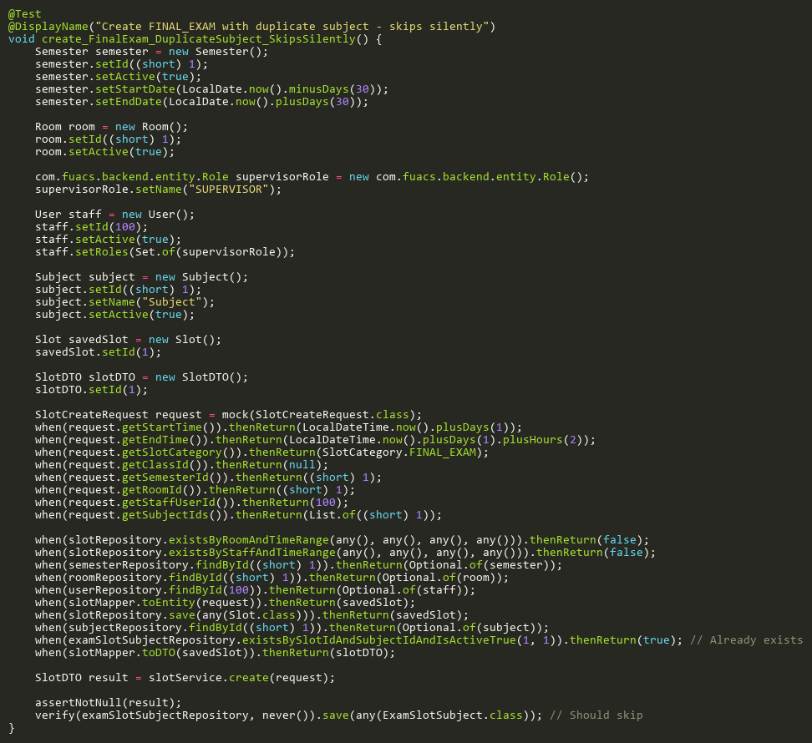

**Figure: create_FinalExam_DuplicateSubject_SkipsSilently**  
*Reference: Sheet "SLST_create", Test Case TC21*

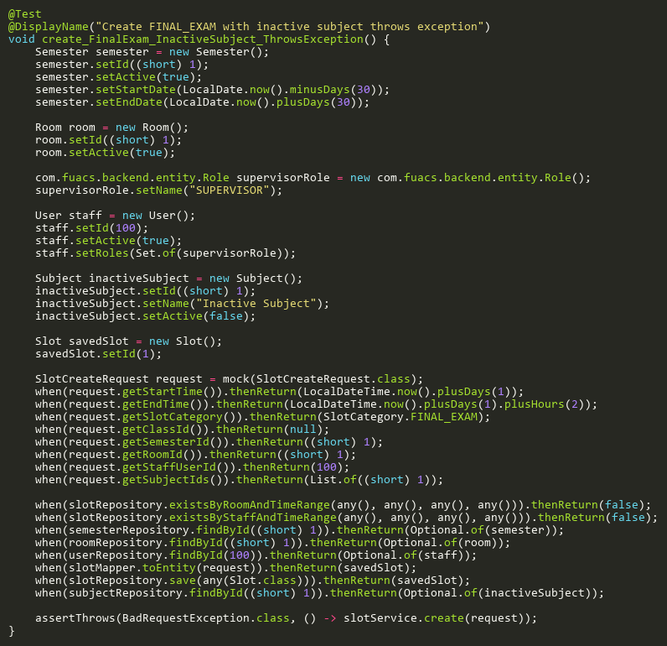

**Figure: create_FinalExam_InactiveSubject_ThrowsException**  
*Reference: Sheet "SLST_create", Test Case TC17*

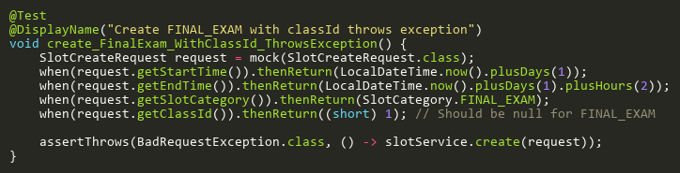

**Figure: create_FinalExam_WithClassId_ThrowsException**  
*Reference: Sheet "SLST_create", Test Case TC22*

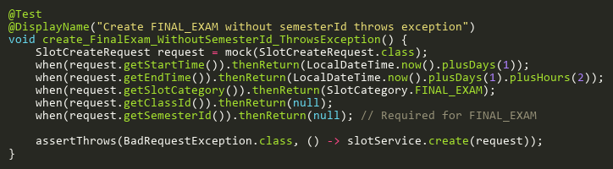

**Figure: create_FinalExam_WithoutSemesterId_ThrowsException**  
*Reference: Sheet "SLST_create", Test Case TC23*

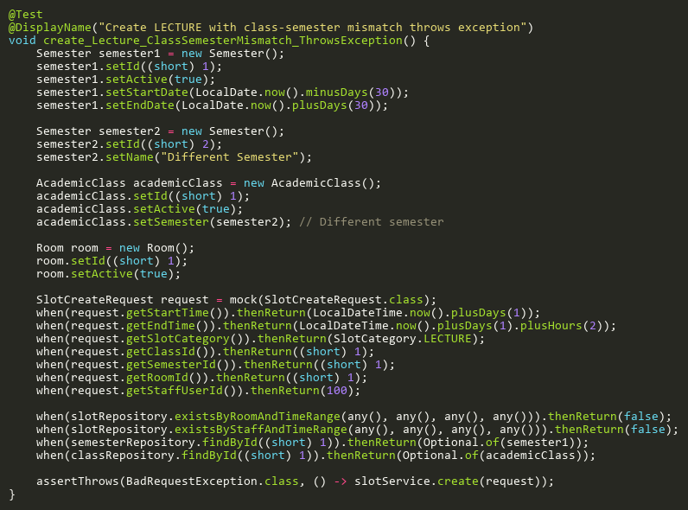

**Figure: create_Lecture_ClassSemesterMismatch_ThrowsException**  
*Reference: Sheet "SLST_create", Test Case TC24*

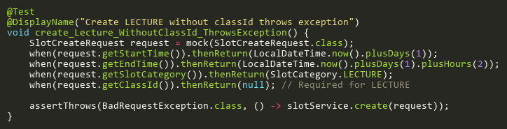

**Figure: create_Lecture_WithoutClassId_ThrowsException**  
*Reference: Sheet "SLST_create", Test Case TC25*

## CreateInitialAttendanceRecordsTests

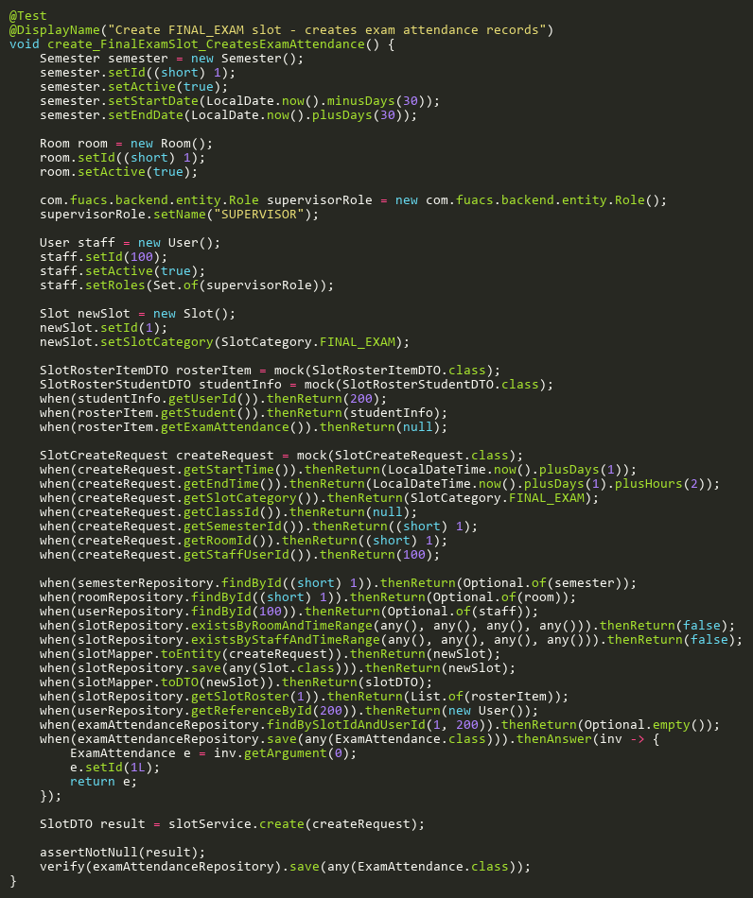

**Figure: create_FinalExamSlot_CreatesExamAttendance**  
*Reference: Sheet "SLST_create", Test Case TC19*

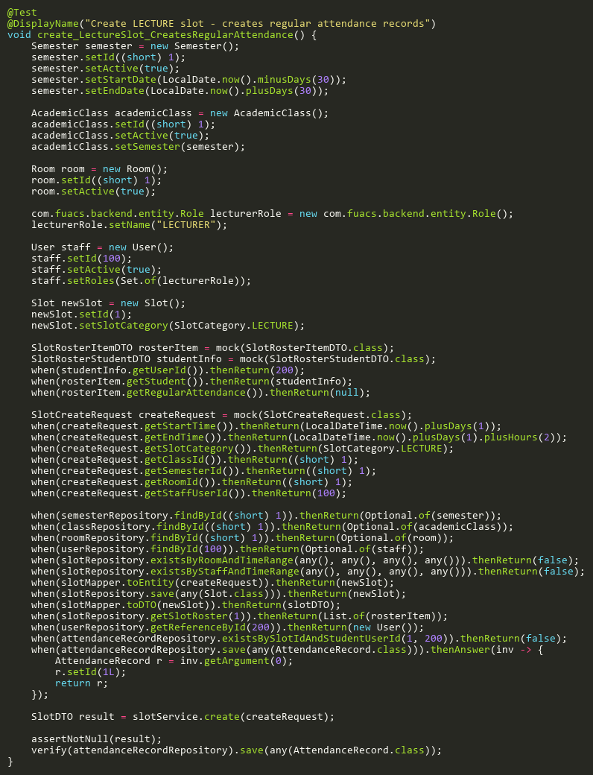

**Figure: create_LectureSlot_CreatesRegularAttendance**  
*Reference: Sheet "SLST_create", Test Case TC18*

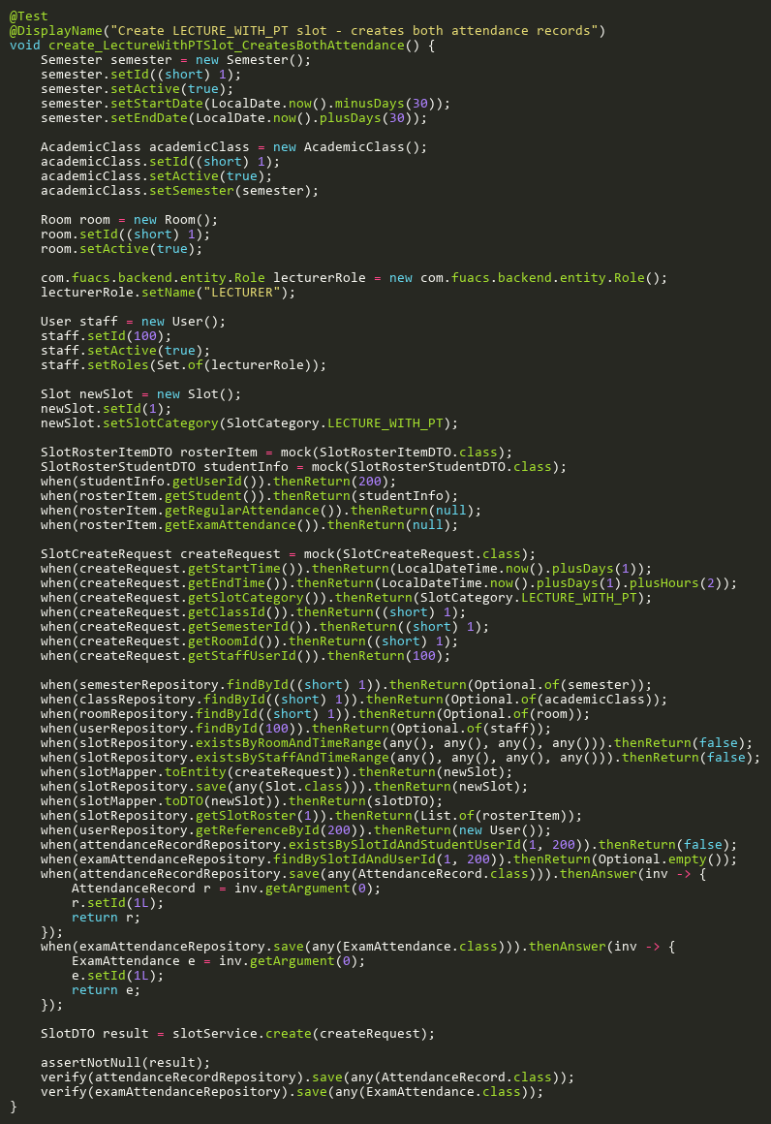

**Figure: create_LectureWithPTSlot_CreatesBothAttendance**  
*Reference: Sheet "SLST_create", Test Case TC20*

## CreateTests

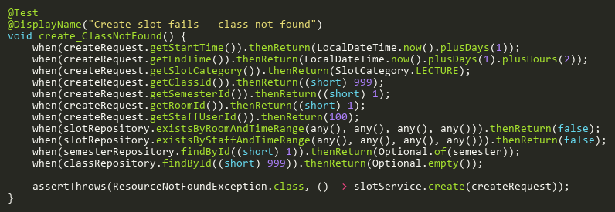

**Figure: create_ClassNotFound**  
*Reference: Sheet "SLST_create", Test Case TC11*

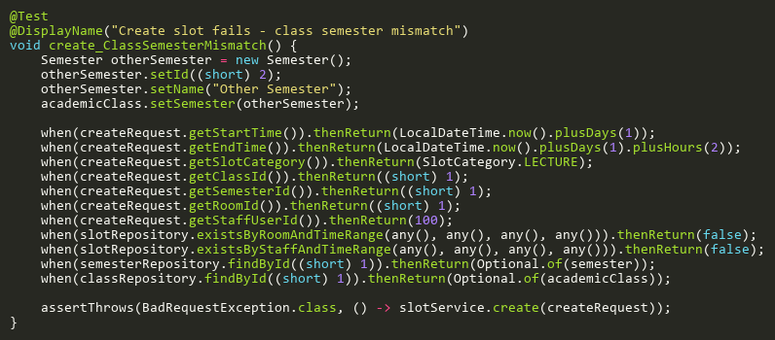

**Figure: create_ClassSemesterMismatch**  
*Reference: Sheet "SLST_create", Test Case TC13*

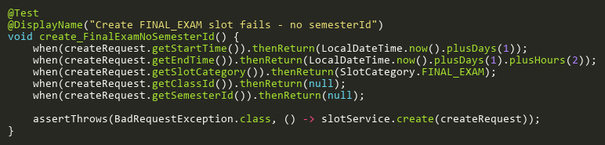

**Figure: create_FinalExamNoSemesterId**  
*Reference: Sheet "SLST_create", Test Case TC04*

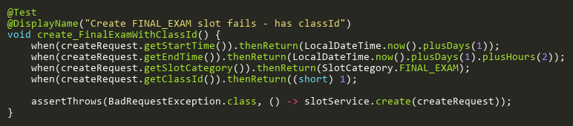

**Figure: create_FinalExamWithClassId**  
*Reference: Sheet "SLST_create", Test Case TC03*

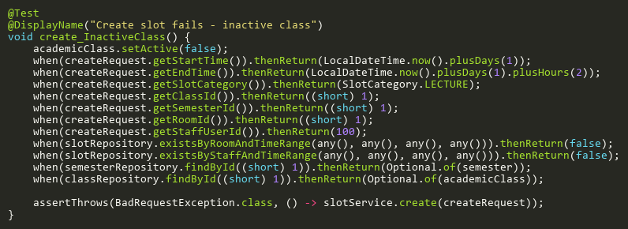

**Figure: create_InactiveClass**  
*Reference: Sheet "SLST_create", Test Case TC12*

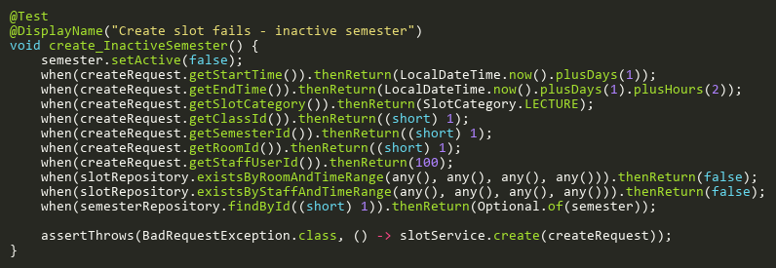

**Figure: create_InactiveSemester**  
*Reference: Sheet "SLST_create", Test Case TC09*

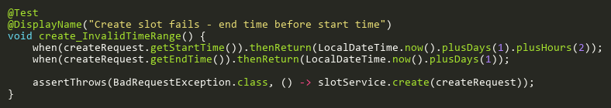

**Figure: create_InvalidTimeRange**  
*Reference: Sheet "SLST_create", Test Case TC02*

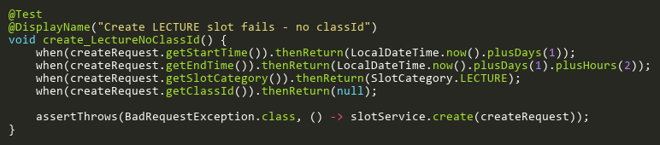

**Figure: create_LectureNoClassId**  
*Reference: Sheet "SLST_create", Test Case TC05*

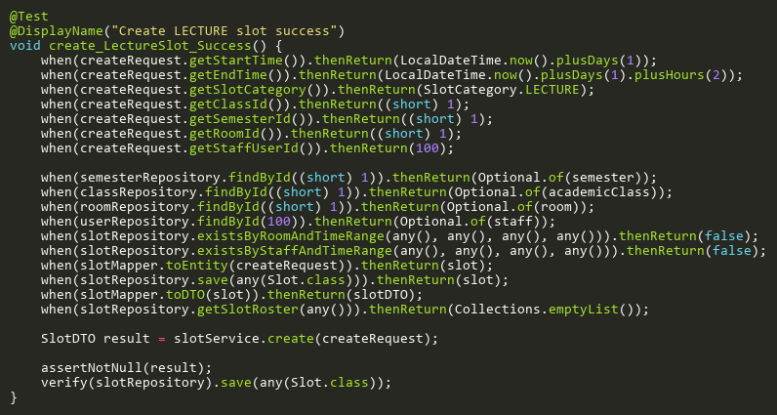

**Figure: create_LectureSlot_Success**  
*Reference: Sheet "SLST_create", Test Case TC01*

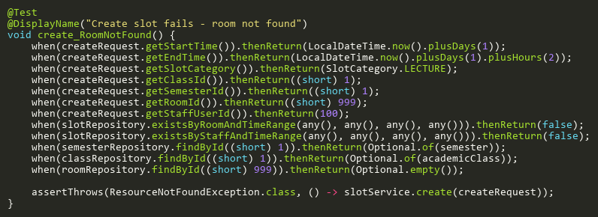

**Figure: create_RoomNotFound**  
*Reference: Sheet "SLST_create", Test Case TC14*

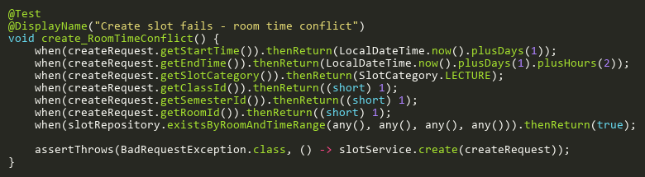

**Figure: create_RoomTimeConflict**  
*Reference: Sheet "SLST_create", Test Case TC06*

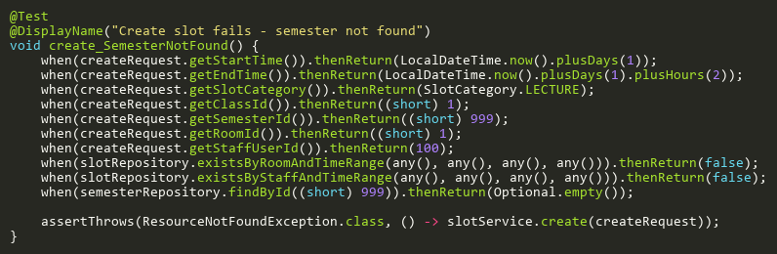

**Figure: create_SemesterNotFound**  
*Reference: Sheet "SLST_create", Test Case TC08*

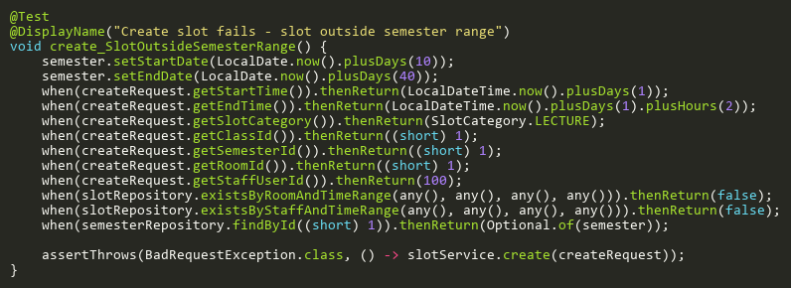

**Figure: create_SlotOutsideSemesterRange**  
*Reference: Sheet "SLST_create", Test Case TC10*

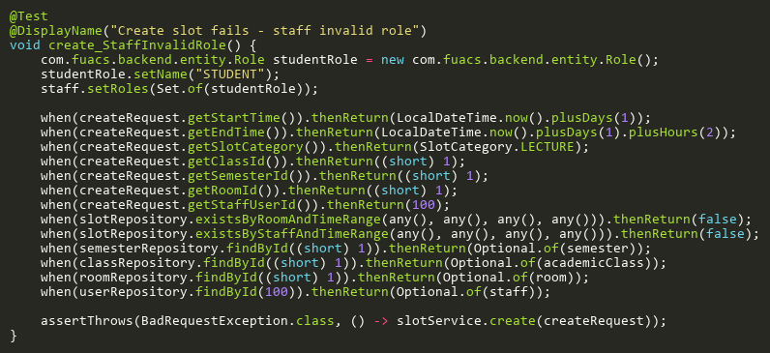

**Figure: create_StaffInvalidRole**  
*Reference: Sheet "SLST_create", Test Case TC16*

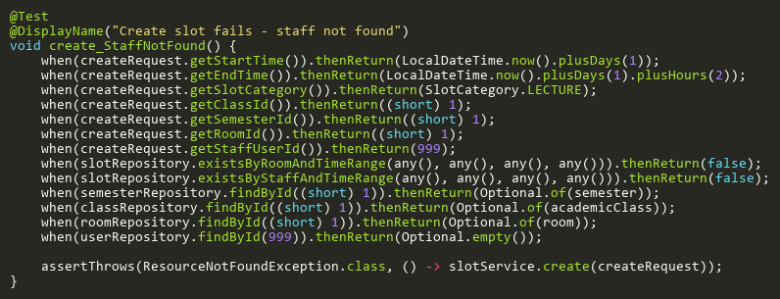

**Figure: create_StaffNotFound**  
*Reference: Sheet "SLST_create", Test Case TC15*

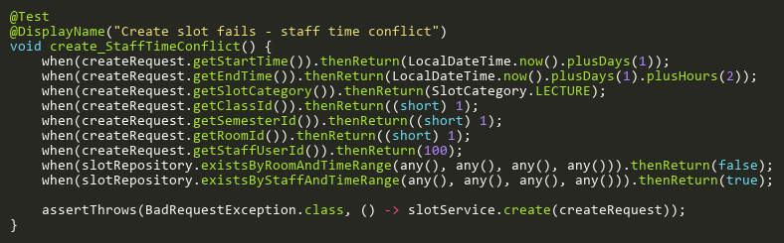

**Figure: create_StaffTimeConflict**  
*Reference: Sheet "SLST_create", Test Case TC07*

## DeleteAdditionalTests

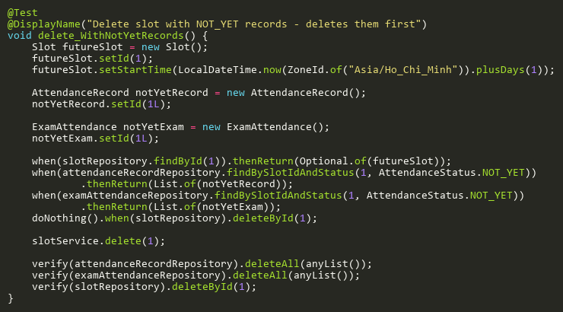

**Figure: delete_WithNotYetRecords**  
*Reference: Sheet "SLST_delete", Test Case TC05*

## DeleteTests

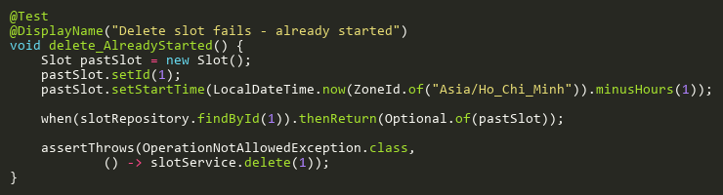

**Figure: delete_AlreadyStarted**  
*Reference: Sheet "SLST_delete", Test Case TC03*

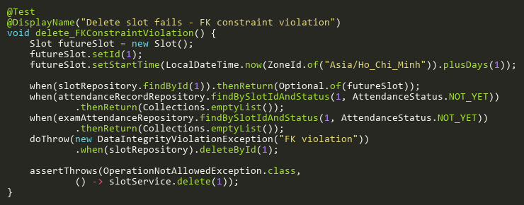

**Figure: delete_FKConstraintViolation**  
*Reference: Sheet "SLST_delete", Test Case TC04*

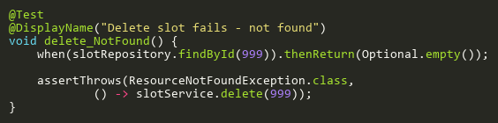

**Figure: delete_NotFound**  
*Reference: Sheet "SLST_delete", Test Case TC02*

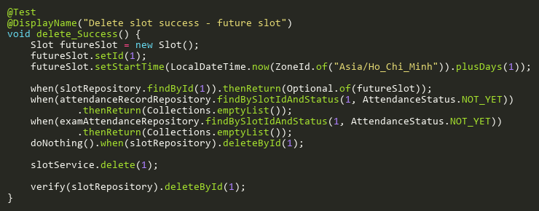

**Figure: delete_Success**  
*Reference: Sheet "SLST_delete", Test Case TC01*

## EnsureAttendanceRecordsExistTests

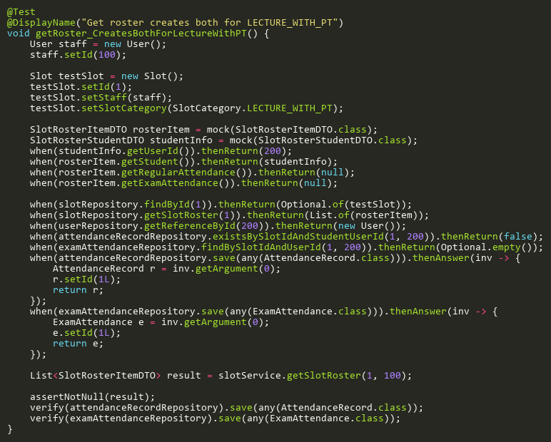

**Figure: getRoster_CreatesBothForLectureWithPT**  
*Reference: Sheet "SLST_ensureRecords", Test Case TC03*

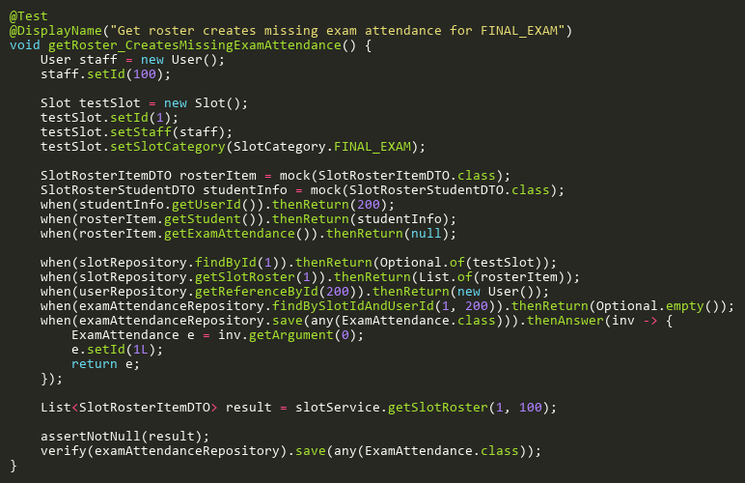

**Figure: getRoster_CreatesMissingExamAttendance**  
*Reference: Sheet "SLST_ensureRecords", Test Case TC02*

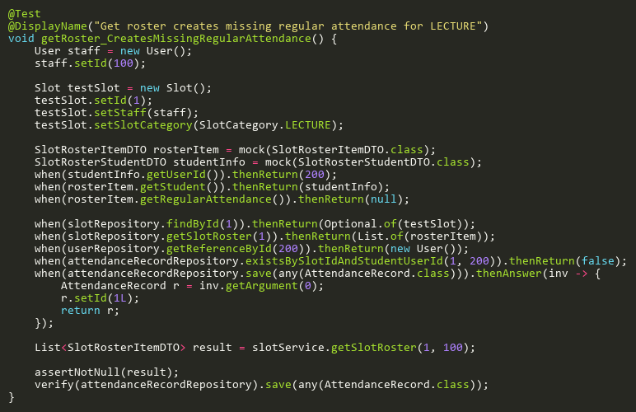

**Figure: getRoster_CreatesMissingRegularAttendance**  
*Reference: Sheet "SLST_ensureRecords", Test Case TC01*

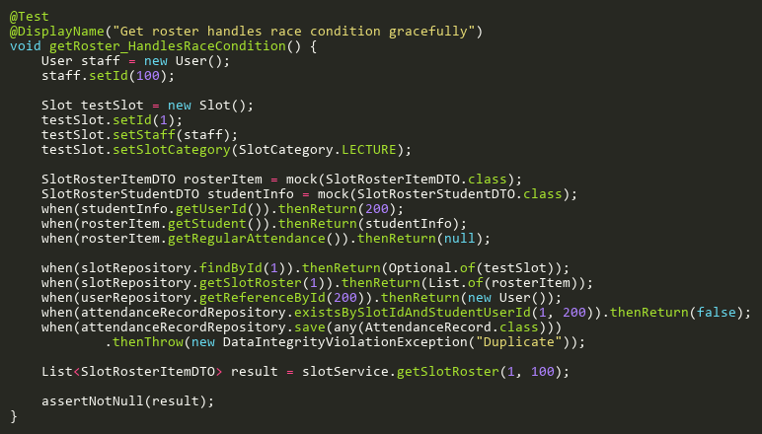

**Figure: getRoster_HandlesRaceCondition**  
*Reference: Sheet "SLST_ensureRecords", Test Case TC05*

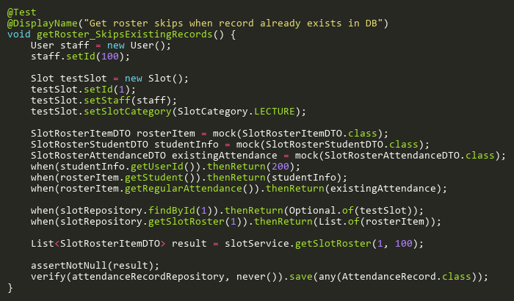

**Figure: getRoster_SkipsExistingRecords**  
*Reference: Sheet "SLST_ensureRecords", Test Case TC04*

## HasAttendanceRecordsTests

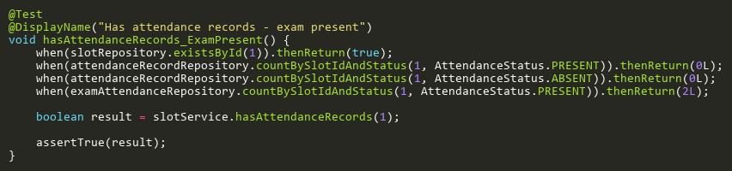

**Figure: hasAttendanceRecords_ExamPresent**  
*Reference: Sheet "SLST_hasRecords", Test Case TC03*

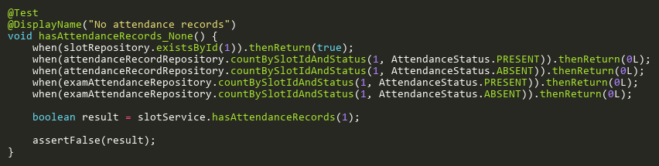

**Figure: hasAttendanceRecords_None**  
*Reference: Sheet "SLST_hasRecords", Test Case TC04*

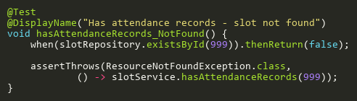

**Figure: hasAttendanceRecords_NotFound**  
*Reference: Sheet "SLST_hasRecords", Test Case TC05*

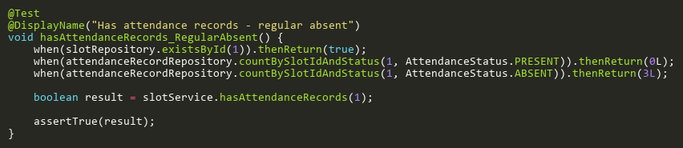

**Figure: hasAttendanceRecords_RegularAbsent**  
*Reference: Sheet "SLST_hasRecords", Test Case TC02*

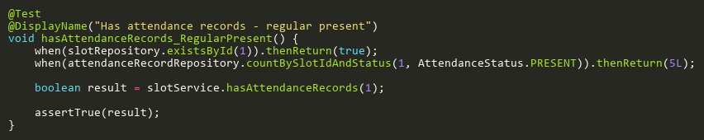

**Figure: hasAttendanceRecords_RegularPresent**  
*Reference: Sheet "SLST_hasRecords", Test Case TC01*

## IsValidCategoryTransitionTests

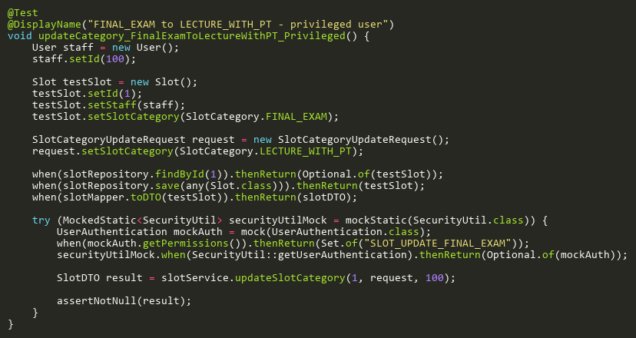

**Figure: updateCategory_FinalExamToLectureWithPT_Privileged**  
*Reference: Sheet "SLST_updateCategory", Test Case TC09*

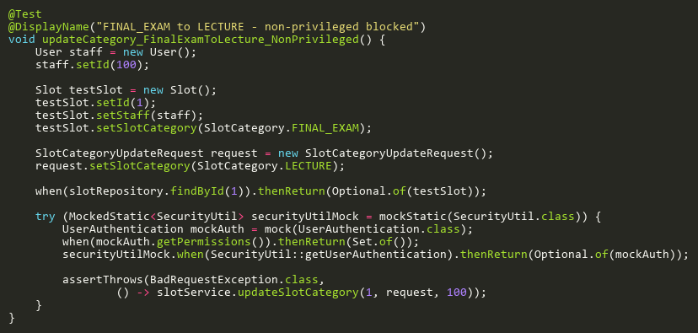

**Figure: updateCategory_FinalExamToLecture_NonPrivileged**  
*Reference: Sheet "SLST_updateCategory", Test Case TC12*

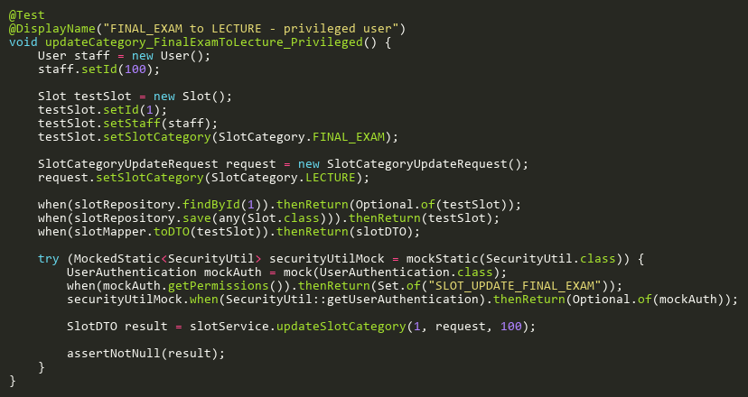

**Figure: updateCategory_FinalExamToLecture_Privileged**  
*Reference: Sheet "SLST_updateCategory", Test Case TC10*

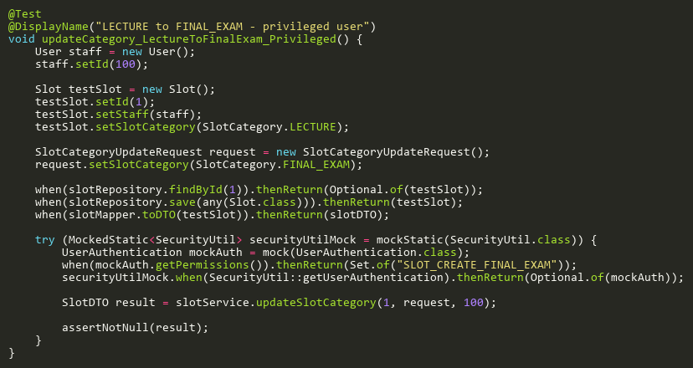

**Figure: updateCategory_LectureToFinalExam_Privileged**  
*Reference: Sheet "SLST_updateCategory", Test Case TC11*

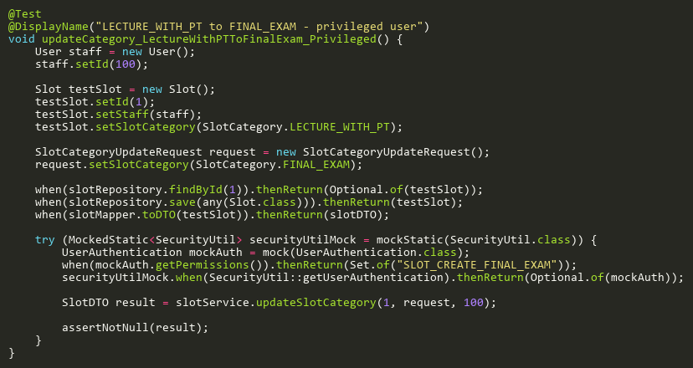

**Figure: updateCategory_LectureWithPTToFinalExam_Privileged**  
*Reference: Sheet "SLST_updateCategory", Test Case TC07*

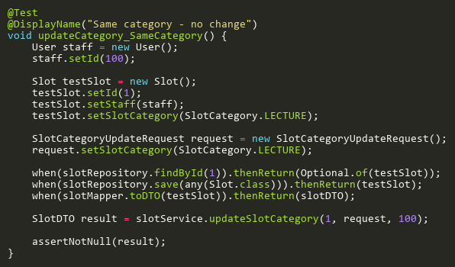

**Figure: updateCategory_SameCategory**  
*Reference: Sheet "SLST_updateCategory", Test Case TC08*

## ProcessNotYetResolutionTests

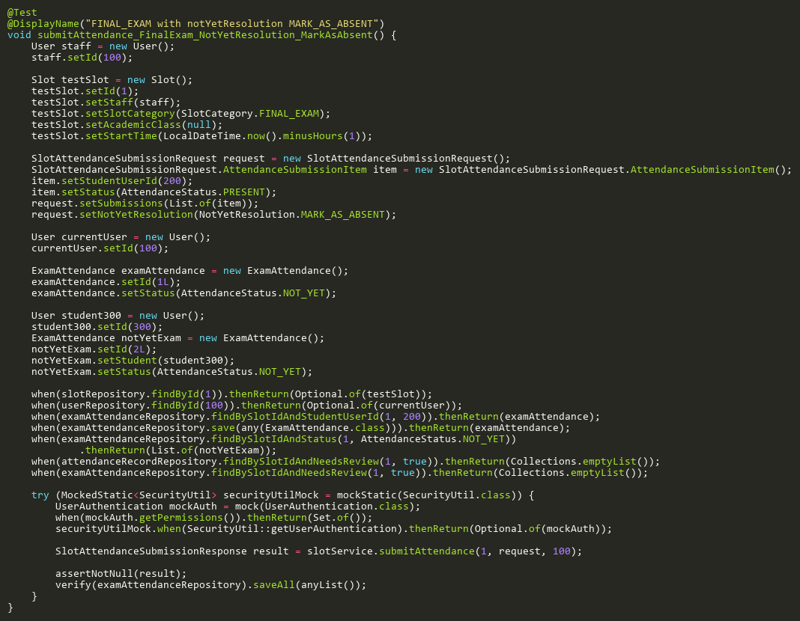

**Figure: submitAttendance_FinalExam_NotYetResolution_MarkAsAbsent**  
*Reference: Sheet "SLST_submitAtt", Test Case TC18*

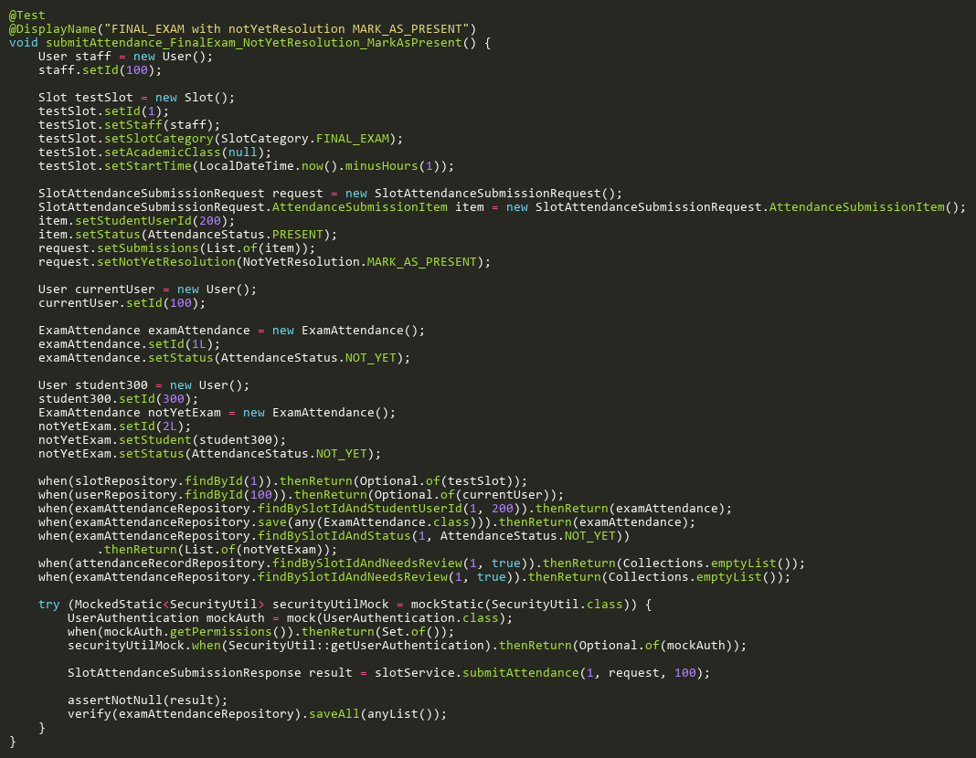

**Figure: submitAttendance_FinalExam_NotYetResolution_MarkAsPresent**  
*Reference: Sheet "SLST_submitAtt", Test Case TC21*

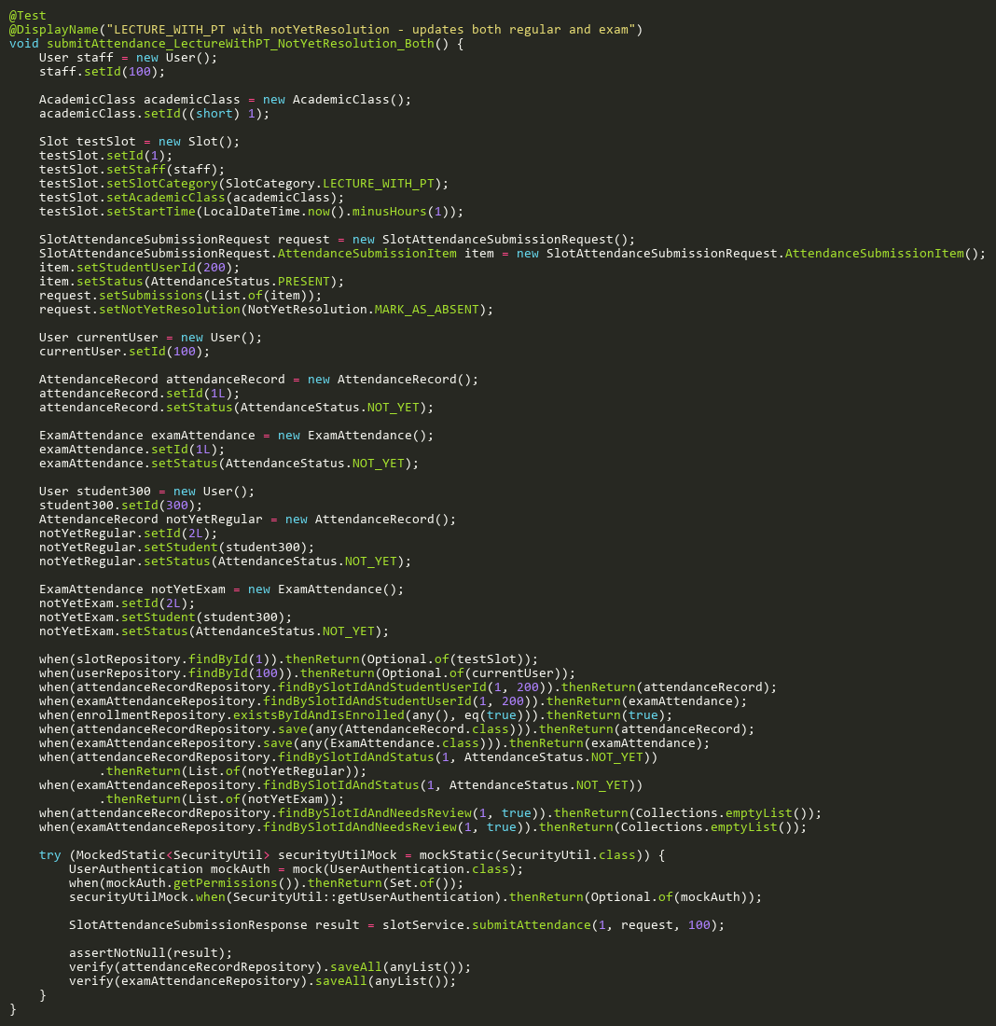

**Figure: submitAttendance_LectureWithPT_NotYetResolution_Both**  
*Reference: Sheet "SLST_submitAtt", Test Case TC22*

## ProcessSingleSubmissionBranchTests

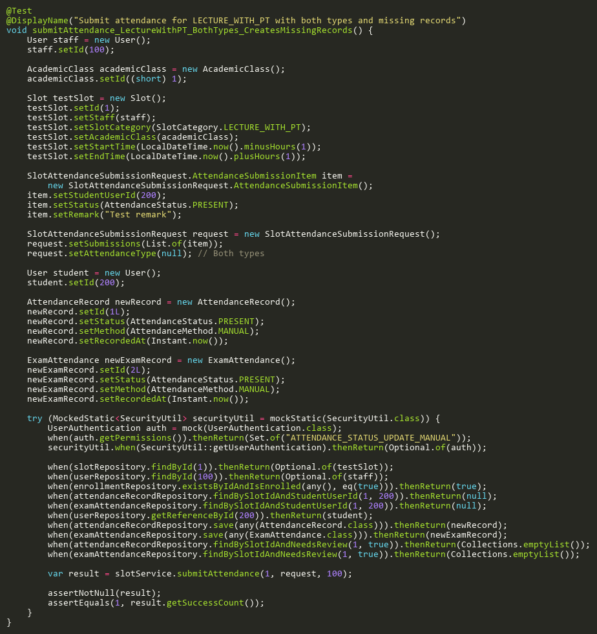

**Figure: submitAttendance_LectureWithPT_BothTypes_CreatesMissingRecords**  
*Reference: Sheet "SLST_submitAtt", Test Case TC17*

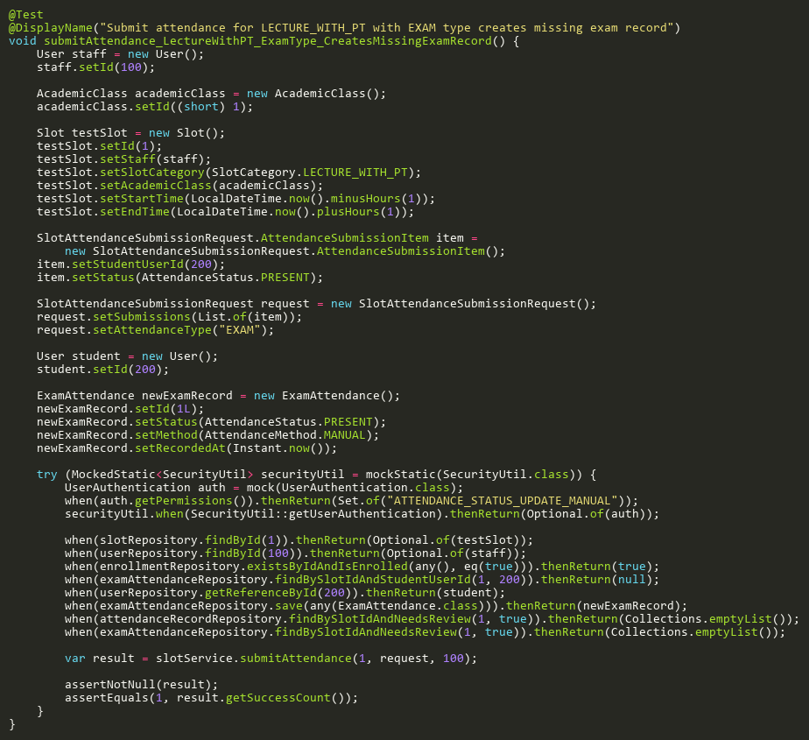

**Figure: submitAttendance_LectureWithPT_ExamType_CreatesMissingExamRecord**  
*Reference: Sheet "SLST_submitAtt", Test Case TC29*

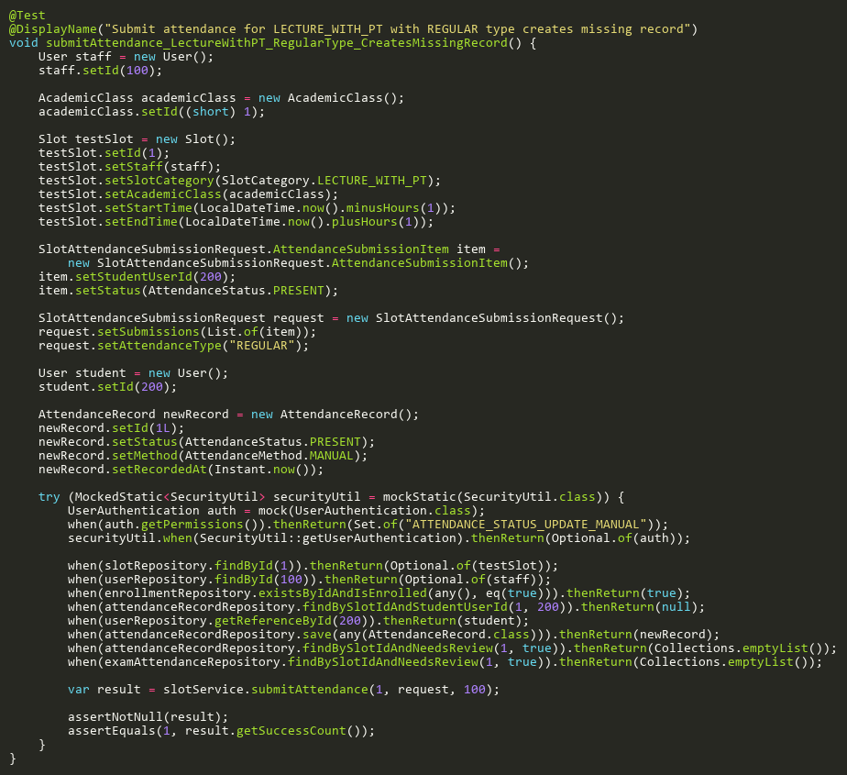

**Figure: submitAttendance_LectureWithPT_RegularType_CreatesMissingRecord**  
*Reference: Sheet "SLST_submitAtt", Test Case TC28*

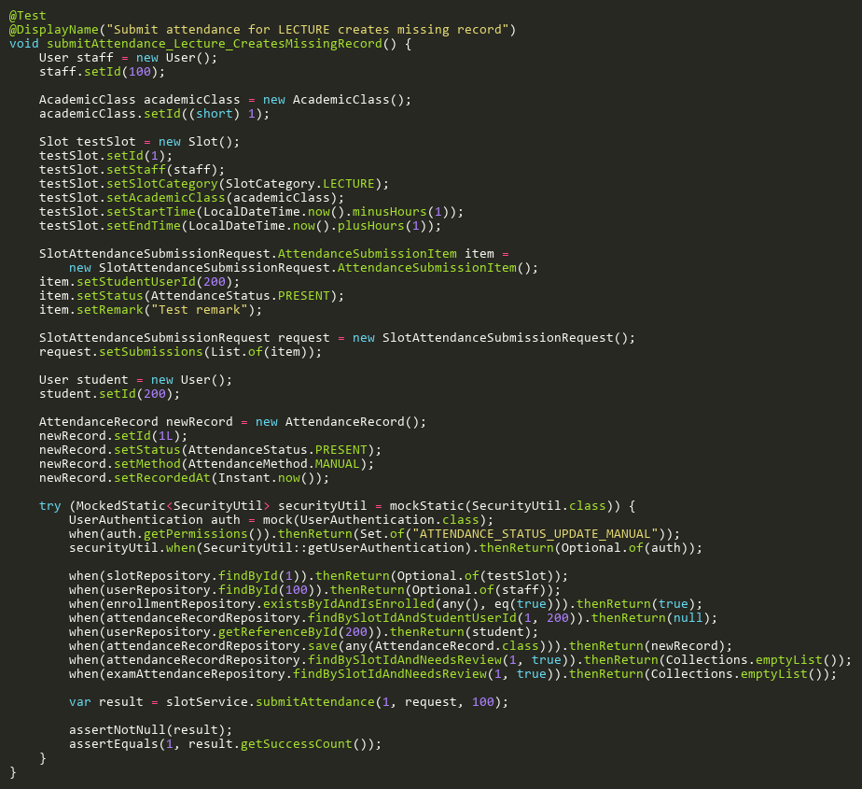

**Figure: submitAttendance_Lecture_CreatesMissingRecord**  
*Reference: Sheet "SLST_submitAtt", Test Case TC26*

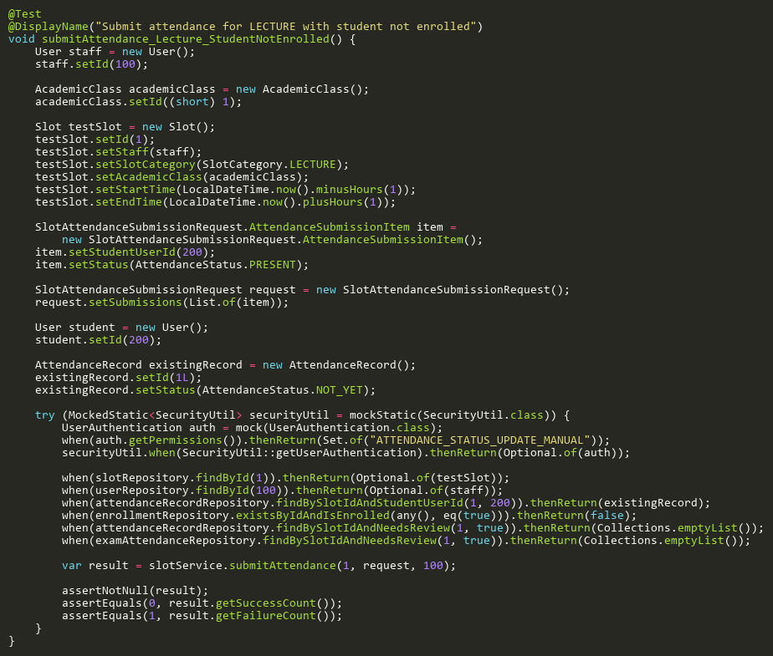

**Figure: submitAttendance_Lecture_StudentNotEnrolled**  
*Reference: Sheet "SLST_submitAtt", Test Case TC27*

## RescanExamTests

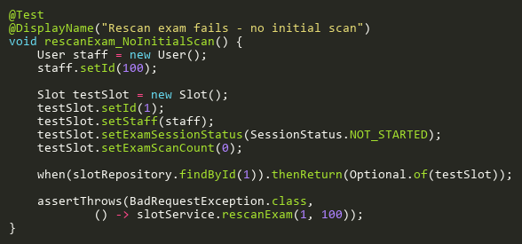

**Figure: rescanExam_NoInitialScan**  
*Reference: Sheet "SLST_rescanExam", Test Case TC03*

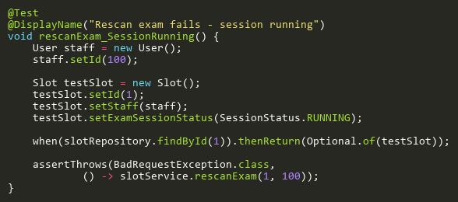

**Figure: rescanExam_SessionRunning**  
*Reference: Sheet "SLST_rescanExam", Test Case TC02*

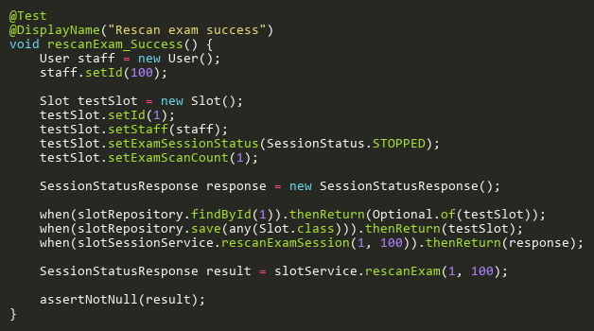

**Figure: rescanExam_Success**  
*Reference: Sheet "SLST_rescanExam", Test Case TC01*

## SearchByStudentIdTests

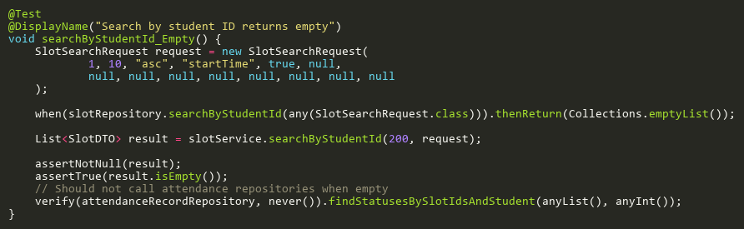

**Figure: searchByStudentId_Empty**  
*Reference: Sheet "SLST_searchStudent", Test Case TC03*

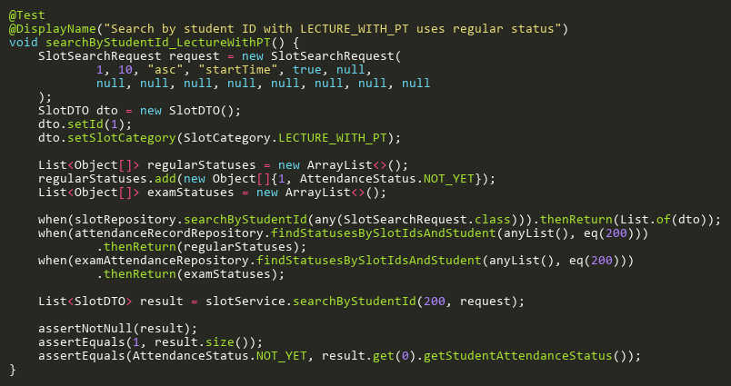

**Figure: searchByStudentId_LectureWithPT**  
*Reference: Sheet "SLST_searchStudent", Test Case TC05*

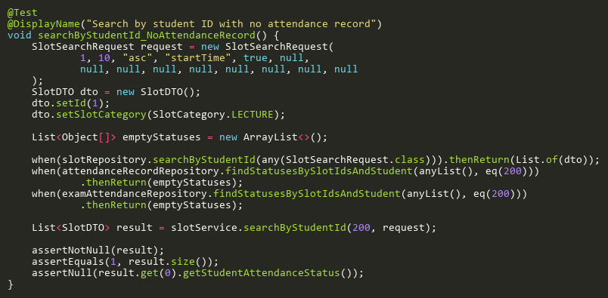

**Figure: searchByStudentId_NoAttendanceRecord**  
*Reference: Sheet "SLST_searchStudent", Test Case TC04*

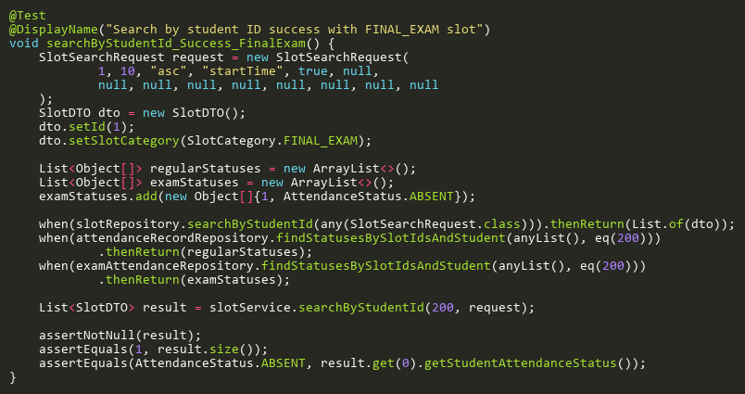

**Figure: searchByStudentId_Success_FinalExam**  
*Reference: Sheet "SLST_searchStudent", Test Case TC02*

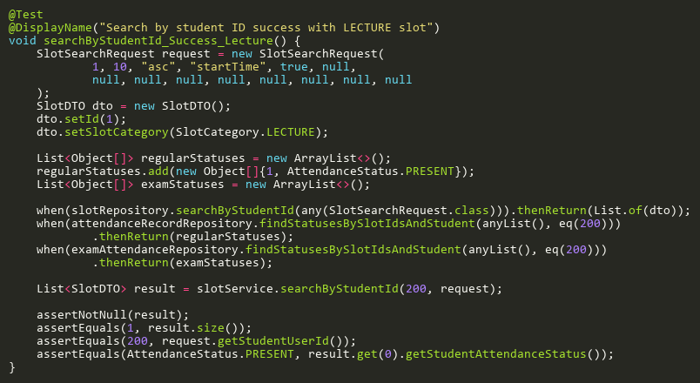

**Figure: searchByStudentId_Success_Lecture**  
*Reference: Sheet "SLST_searchStudent", Test Case TC01*

## StartAttendanceSessionTests

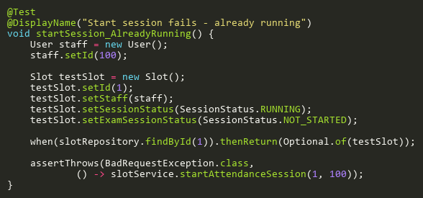

**Figure: startSession_AlreadyRunning**  
*Reference: Sheet "SLST_startSession", Test Case TC05*

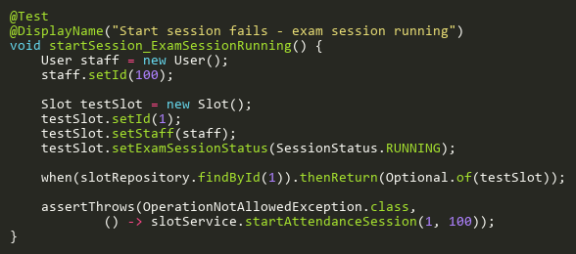

**Figure: startSession_ExamSessionRunning**  
*Reference: Sheet "SLST_startSession", Test Case TC04*

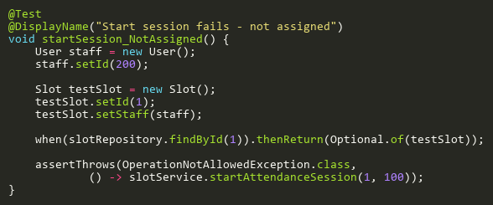

**Figure: startSession_NotAssigned**  
*Reference: Sheet "SLST_startSession", Test Case TC03*

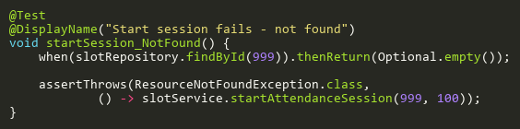

**Figure: startSession_NotFound**  
*Reference: Sheet "SLST_startSession", Test Case TC02*

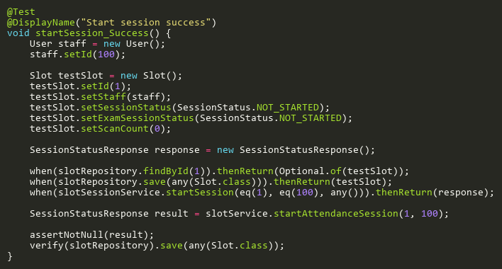

**Figure: startSession_Success**  
*Reference: Sheet "SLST_startSession", Test Case TC01*

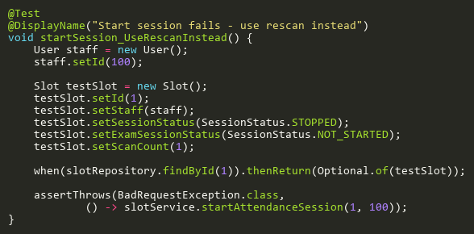

**Figure: startSession_UseRescanInstead**  
*Reference: Sheet "SLST_startSession", Test Case TC06*

## StartExamSessionTests

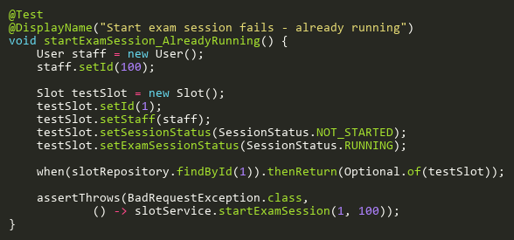

**Figure: startExamSession_AlreadyRunning**  
*Reference: Sheet "SLST_startExam", Test Case TC03*

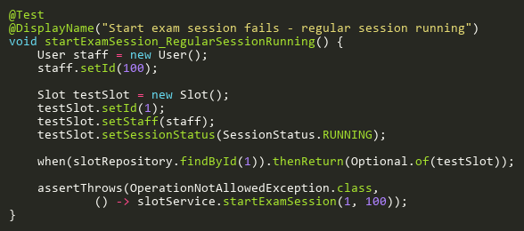

**Figure: startExamSession_RegularSessionRunning**  
*Reference: Sheet "SLST_startExam", Test Case TC02*

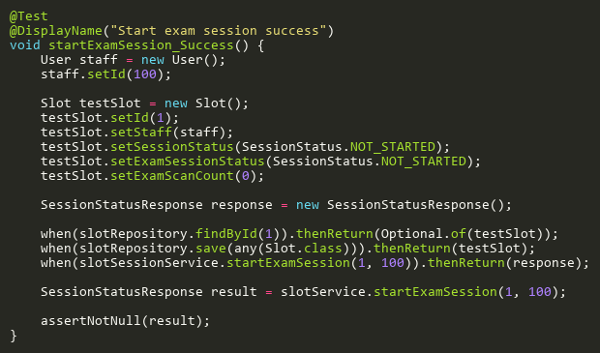

**Figure: startExamSession_Success**  
*Reference: Sheet "SLST_startExam", Test Case TC01*

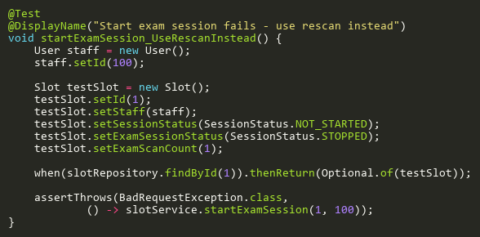

**Figure: startExamSession_UseRescanInstead**  
*Reference: Sheet "SLST_startExam", Test Case TC04*

## StopAttendanceSessionTests

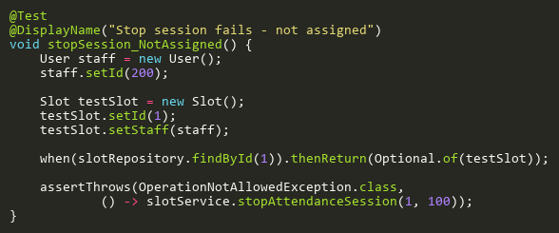

**Figure: stopSession_NotAssigned**  
*Reference: Sheet "SLST_stopSession", Test Case TC02*

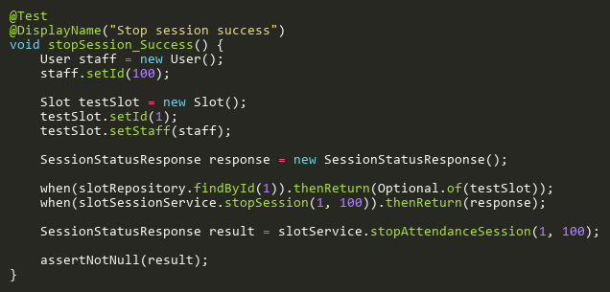

**Figure: stopSession_Success**  
*Reference: Sheet "SLST_stopSession", Test Case TC01*

## StopExamSessionTests

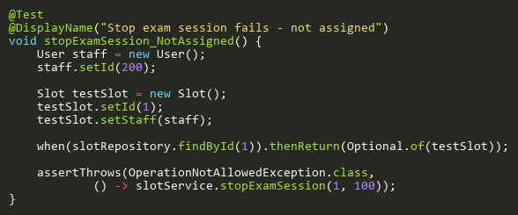

**Figure: stopExamSession_NotAssigned**  
*Reference: Sheet "SLST_stopExam", Test Case TC02*

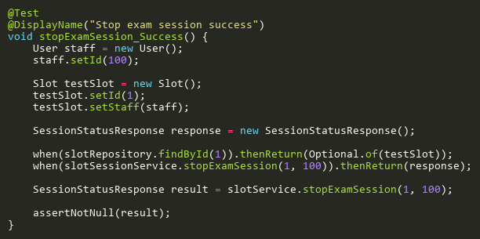

**Figure: stopExamSession_Success**  
*Reference: Sheet "SLST_stopExam", Test Case TC01*

## SubmitAttendanceAdditionalTests

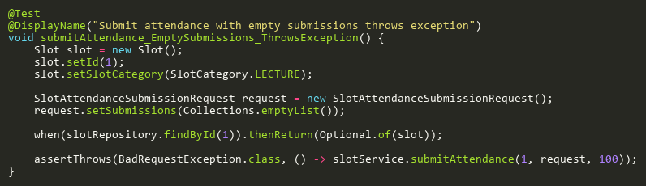

**Figure: submitAttendance_EmptySubmissions_ThrowsException**  
*Reference: Sheet "SLST_submitAtt", Test Case TC24*

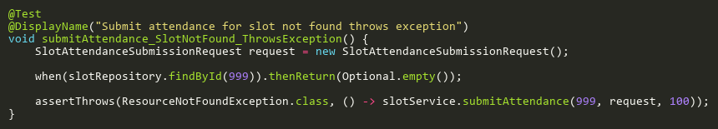

**Figure: submitAttendance_SlotNotFound_ThrowsException**  
*Reference: Sheet "SLST_submitAtt", Test Case TC25*

## SubmitAttendanceTests

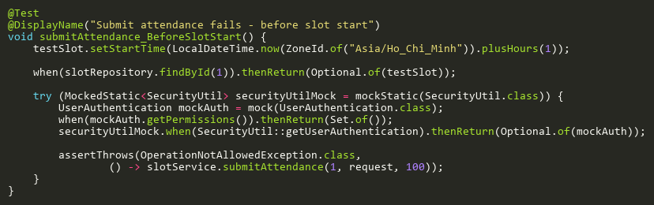

**Figure: submitAttendance_BeforeSlotStart**  
*Reference: Sheet "SLST_submitAtt", Test Case TC05*

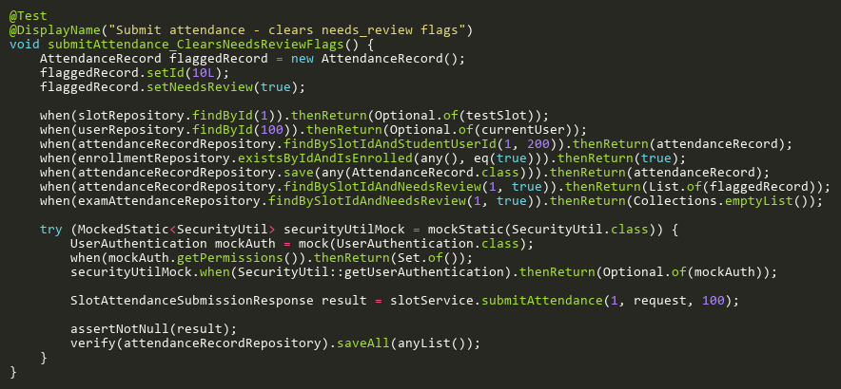

**Figure: submitAttendance_ClearsNeedsReviewFlags**  
*Reference: Sheet "SLST_submitAtt", Test Case TC07*

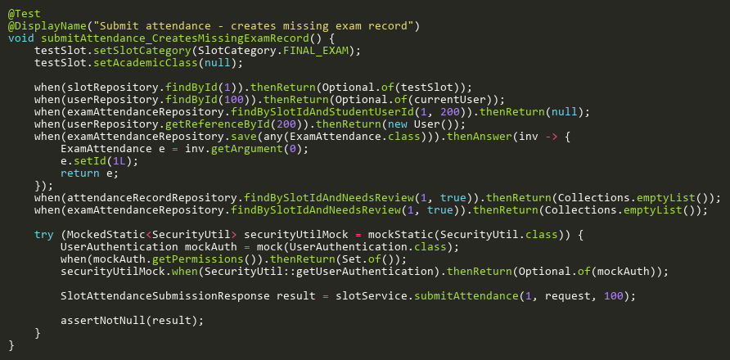

**Figure: submitAttendance_CreatesMissingExamRecord**  
*Reference: Sheet "SLST_submitAtt", Test Case TC16*

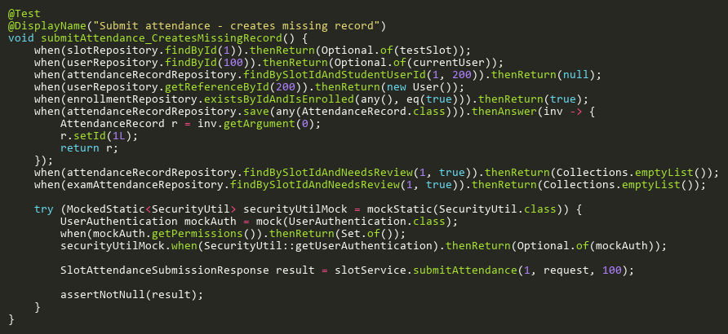

**Figure: submitAttendance_CreatesMissingRecord**  
*Reference: Sheet "SLST_submitAtt", Test Case TC10*

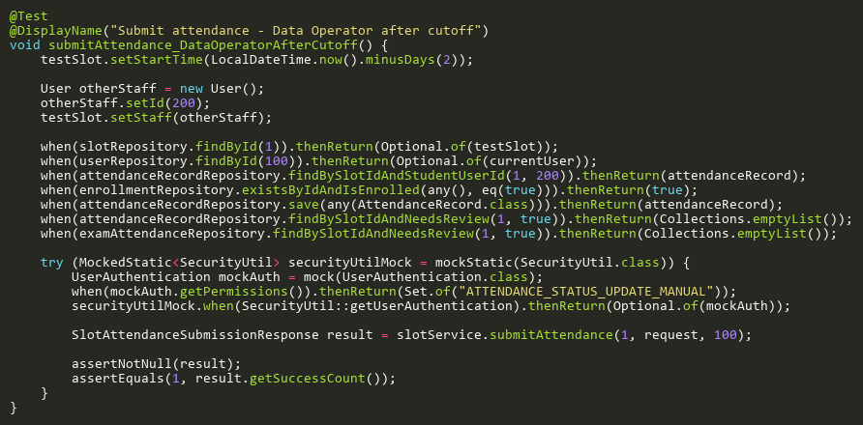

**Figure: submitAttendance_DataOperatorAfterCutoff**  
*Reference: Sheet "SLST_submitAtt", Test Case TC19*

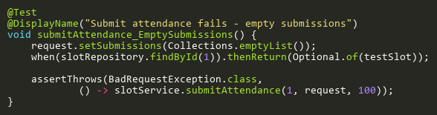

**Figure: submitAttendance_EmptySubmissions**  
*Reference: Sheet "SLST_submitAtt", Test Case TC03*

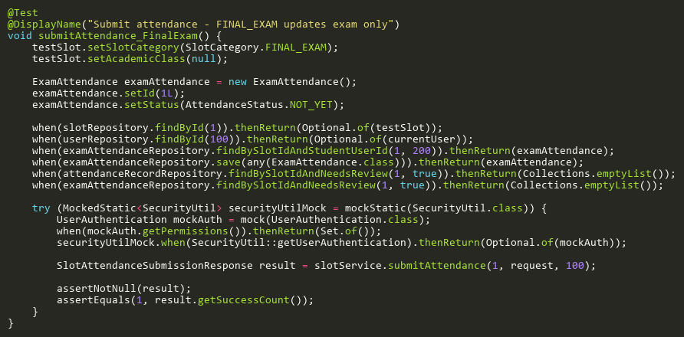

**Figure: submitAttendance_FinalExam**  
*Reference: Sheet "SLST_submitAtt", Test Case TC09*

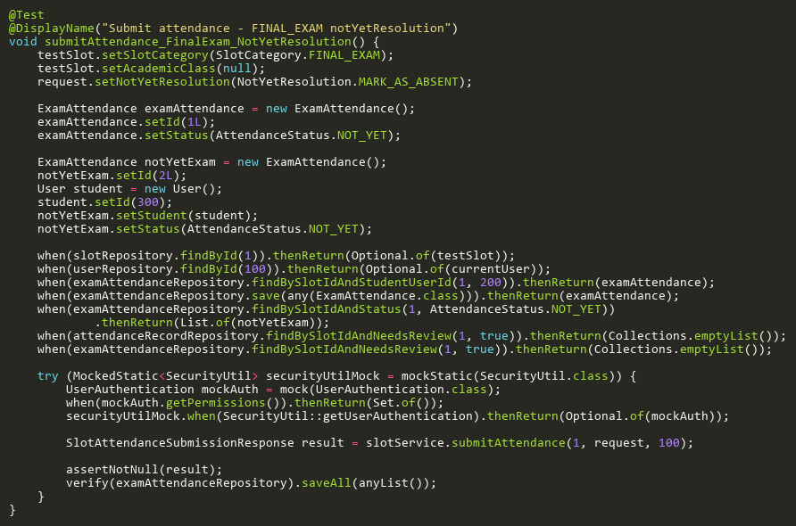

**Figure: submitAttendance_FinalExam_NotYetResolution**  
*Reference: Sheet "SLST_submitAtt", Test Case TC20*

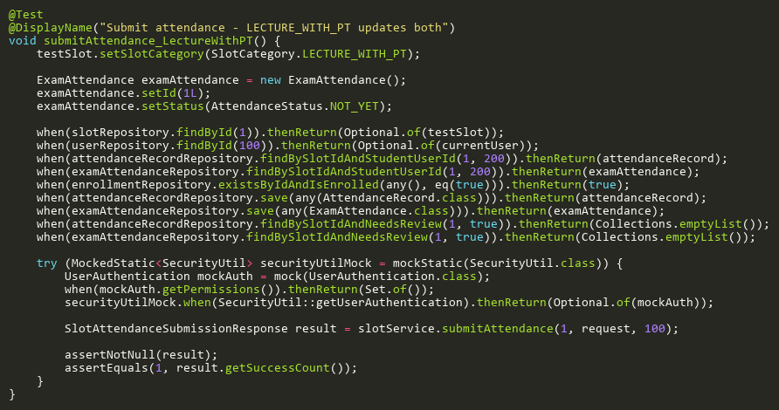

**Figure: submitAttendance_LectureWithPT**  
*Reference: Sheet "SLST_submitAtt", Test Case TC08*

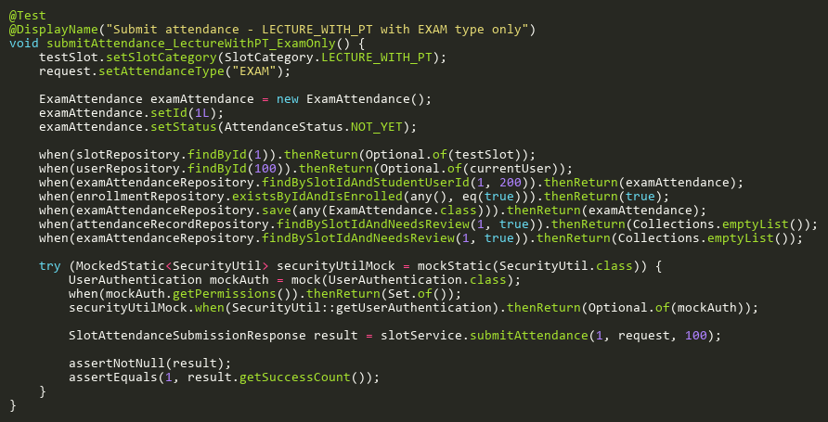

**Figure: submitAttendance_LectureWithPT_ExamOnly**  
*Reference: Sheet "SLST_submitAtt", Test Case TC13*

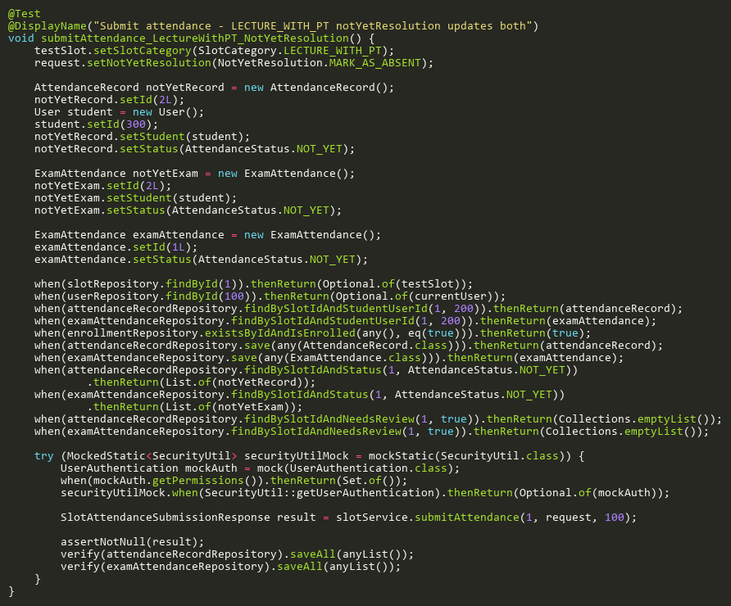

**Figure: submitAttendance_LectureWithPT_NotYetResolution**  
*Reference: Sheet "SLST_submitAtt", Test Case TC15*

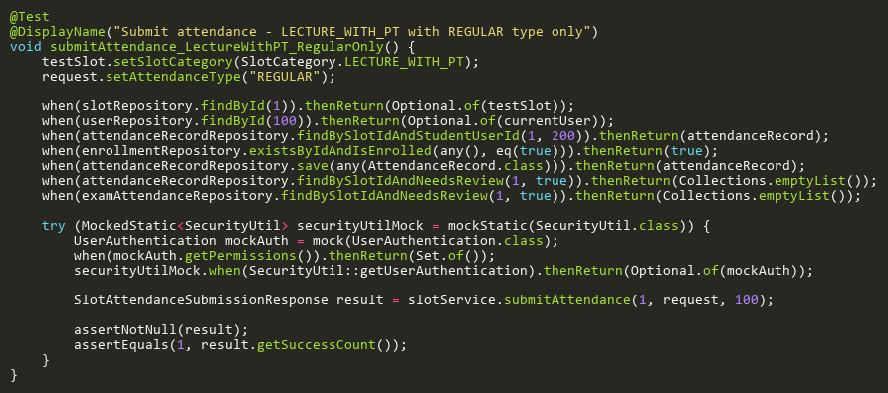

**Figure: submitAttendance_LectureWithPT_RegularOnly**  
*Reference: Sheet "SLST_submitAtt", Test Case TC12*

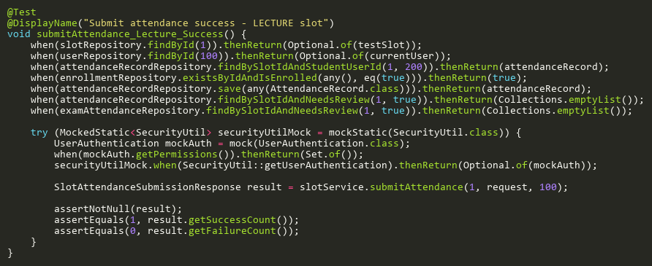

**Figure: submitAttendance_Lecture_Success**  
*Reference: Sheet "SLST_submitAtt", Test Case TC01*

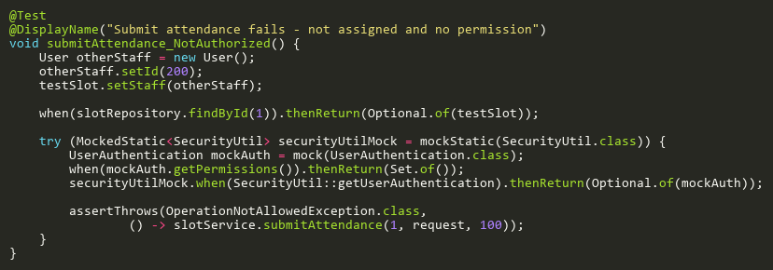

**Figure: submitAttendance_NotAuthorized**  
*Reference: Sheet "SLST_submitAtt", Test Case TC04*

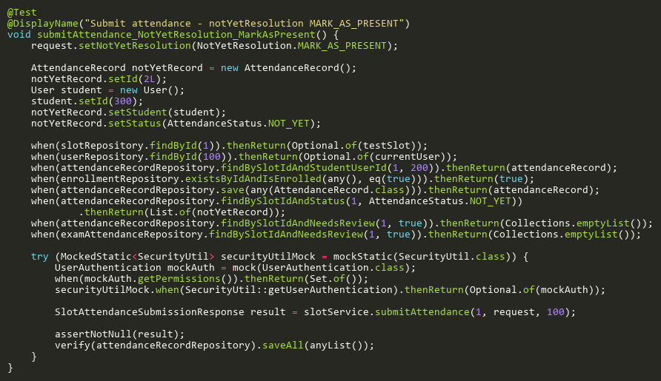

**Figure: submitAttendance_NotYetResolution_MarkAsPresent**  
*Reference: Sheet "SLST_submitAtt", Test Case TC14*

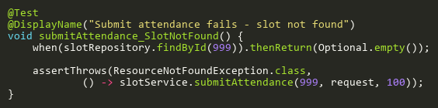

**Figure: submitAttendance_SlotNotFound**  
*Reference: Sheet "SLST_submitAtt", Test Case TC02*

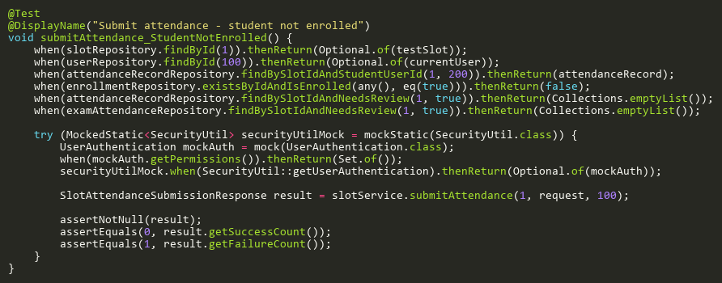

**Figure: submitAttendance_StudentNotEnrolled**  
*Reference: Sheet "SLST_submitAtt", Test Case TC11*

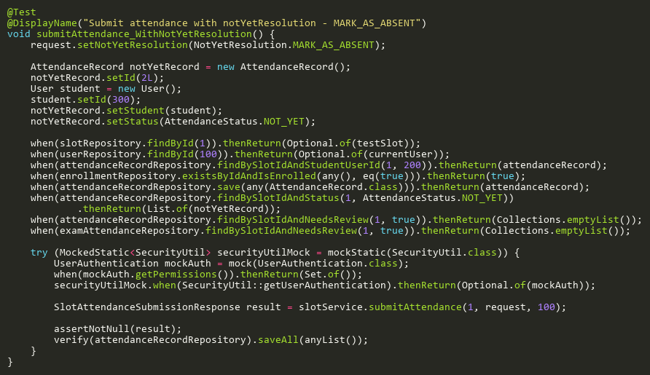

**Figure: submitAttendance_WithNotYetResolution**  
*Reference: Sheet "SLST_submitAtt", Test Case TC06*

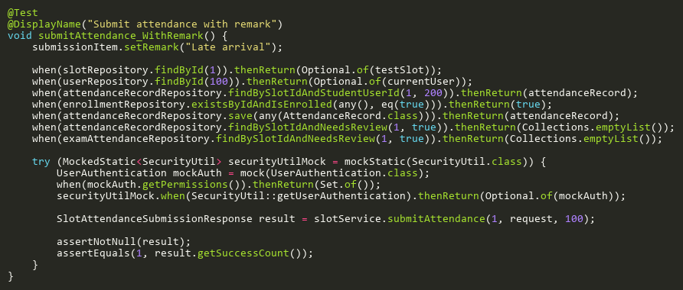

**Figure: submitAttendance_WithRemark**  
*Reference: Sheet "SLST_submitAtt", Test Case TC23*

## TriggerRescanTests

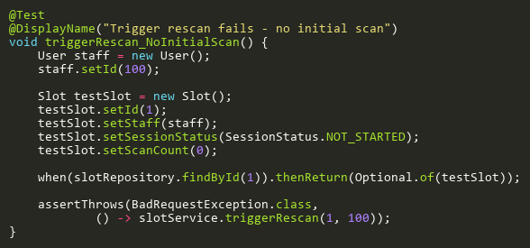

**Figure: triggerRescan_NoInitialScan**  
*Reference: Sheet "SLST_triggerRescan", Test Case TC04*

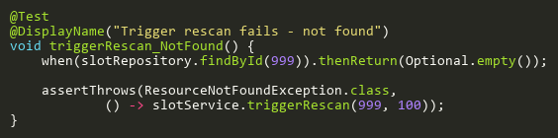

**Figure: triggerRescan_NotFound**  
*Reference: Sheet "SLST_triggerRescan", Test Case TC02*

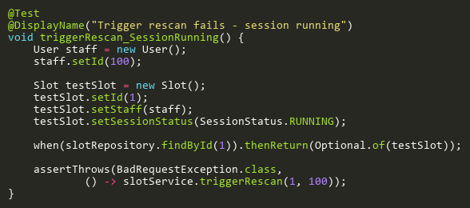

**Figure: triggerRescan_SessionRunning**  
*Reference: Sheet "SLST_triggerRescan", Test Case TC03*

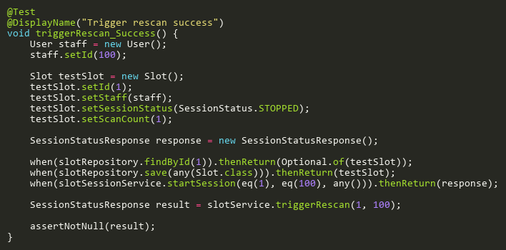

**Figure: triggerRescan_Success**  
*Reference: Sheet "SLST_triggerRescan", Test Case TC01*

## UpdateAdditionalTests

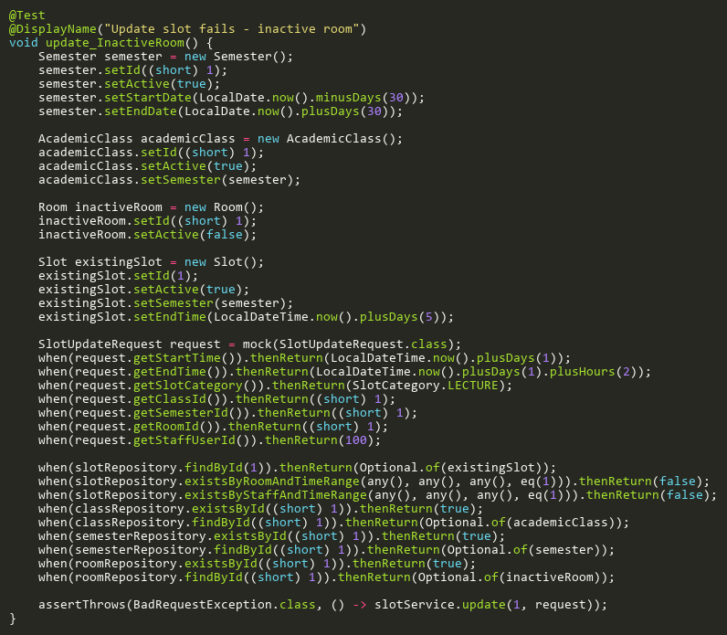

**Figure: update_InactiveRoom**  
*Reference: Sheet "SLST_update", Test Case TC18*

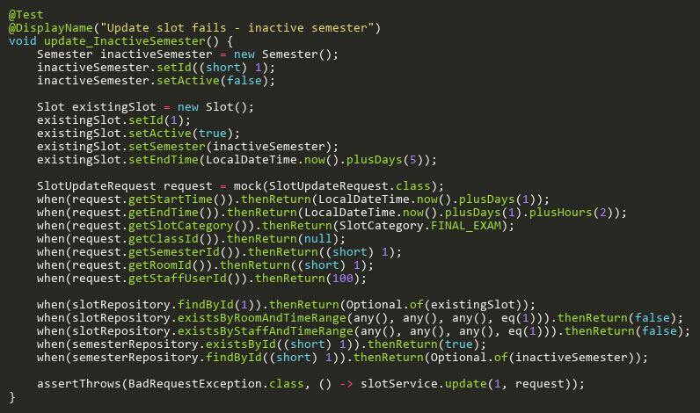

**Figure: update_InactiveSemester**  
*Reference: Sheet "SLST_update", Test Case TC14*

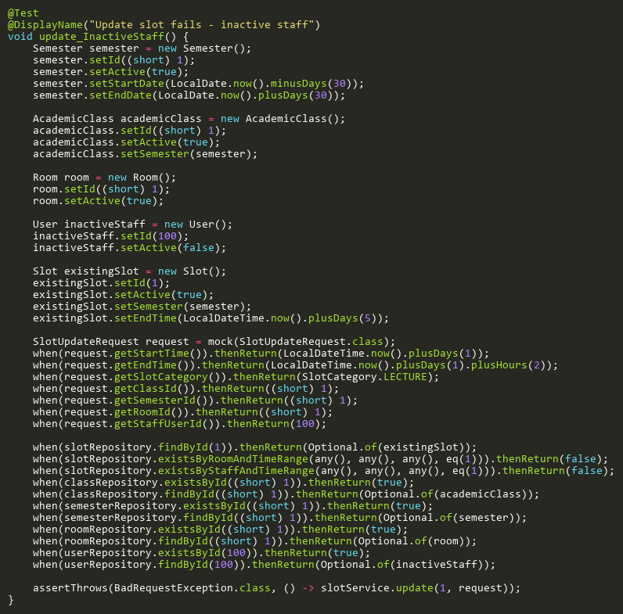

**Figure: update_InactiveStaff**  
*Reference: Sheet "SLST_update", Test Case TC19*

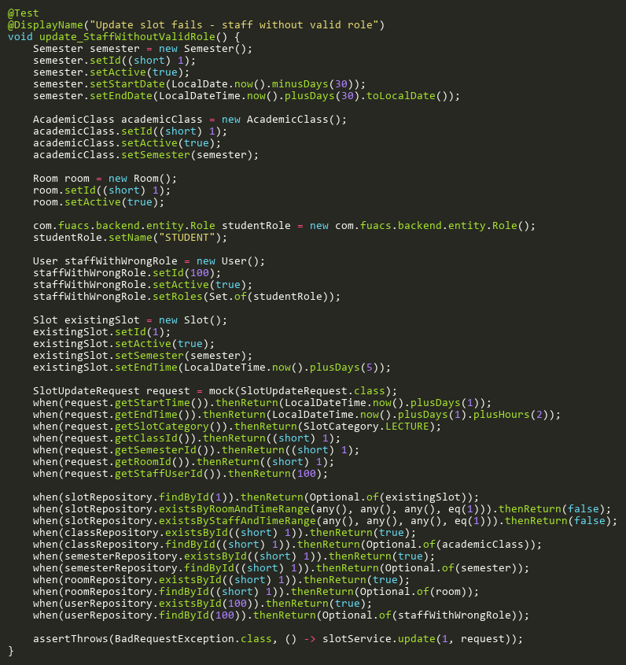

**Figure: update_StaffWithoutValidRole**  
*Reference: Sheet "SLST_update", Test Case TC20*

## UpdateBranchCoverageTests

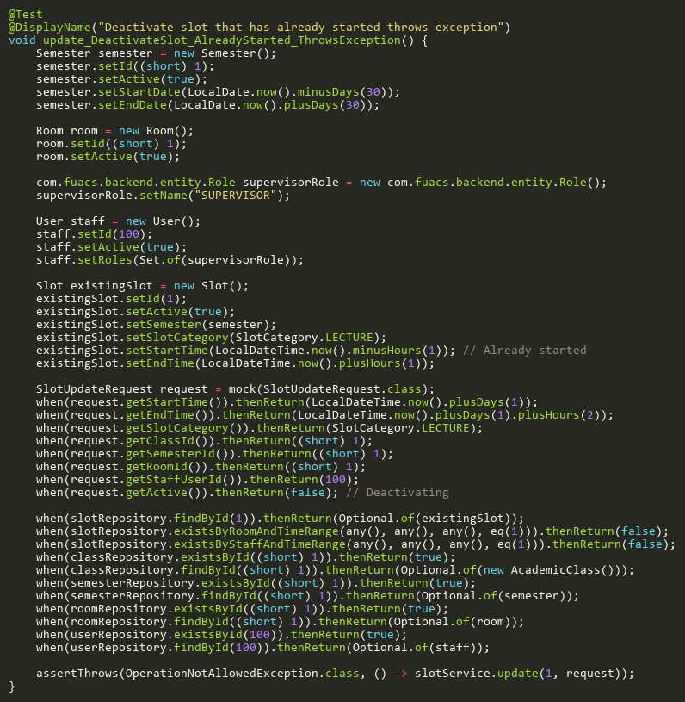

**Figure: update_DeactivateSlot_AlreadyStarted_ThrowsException**  
*Reference: Sheet "SLST_update", Test Case TC15*

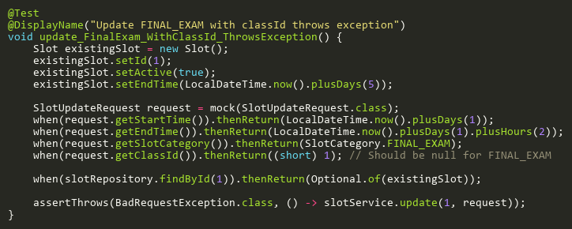

**Figure: update_FinalExam_WithClassId_ThrowsException**  
*Reference: Sheet "SLST_update", Test Case TC16*

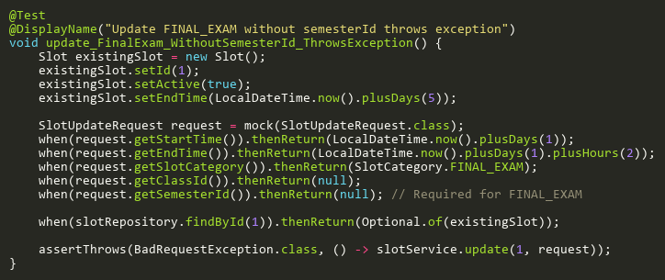

**Figure: update_FinalExam_WithoutSemesterId_ThrowsException**  
*Reference: Sheet "SLST_update", Test Case TC17*

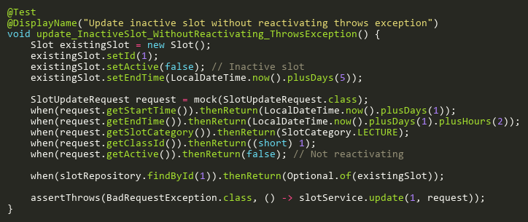

**Figure: update_InactiveSlot_WithoutReactivating_ThrowsException**  
*Reference: Sheet "SLST_update", Test Case TC12*

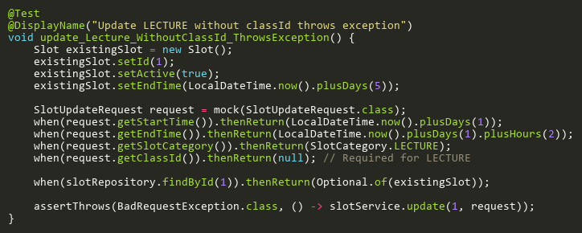

**Figure: update_Lecture_WithoutClassId_ThrowsException**  
*Reference: Sheet "SLST_update", Test Case TC21*

## UpdateSlotCategoryTests

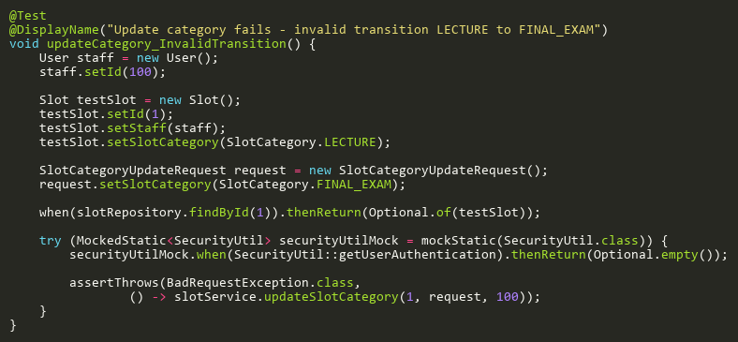

**Figure: updateCategory_InvalidTransition**  
*Reference: Sheet "SLST_updateCategory", Test Case TC05*

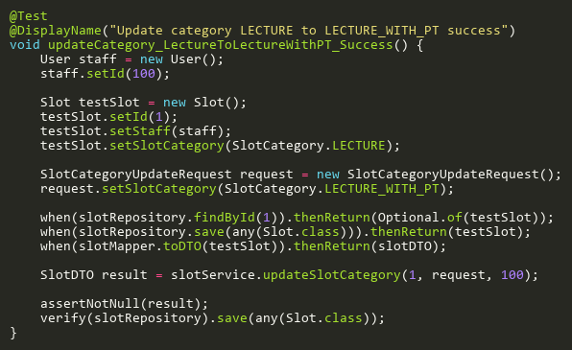

**Figure: updateCategory_LectureToLectureWithPT_Success**  
*Reference: Sheet "SLST_updateCategory", Test Case TC01*

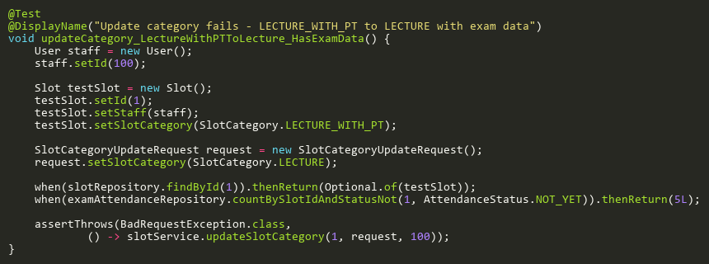

**Figure: updateCategory_LectureWithPTToLecture_HasExamData**  
*Reference: Sheet "SLST_updateCategory", Test Case TC06*

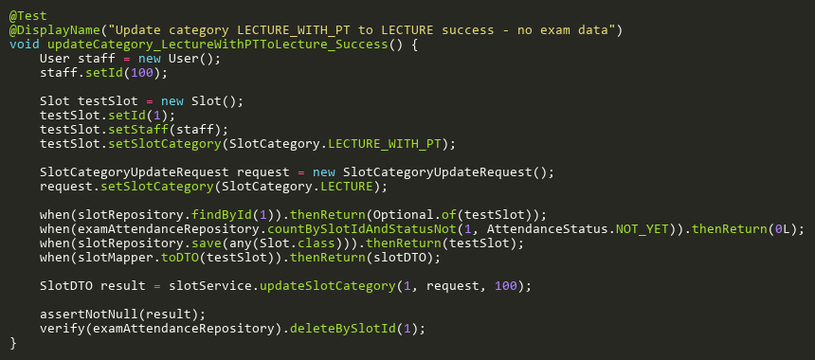

**Figure: updateCategory_LectureWithPTToLecture_Success**  
*Reference: Sheet "SLST_updateCategory", Test Case TC02*

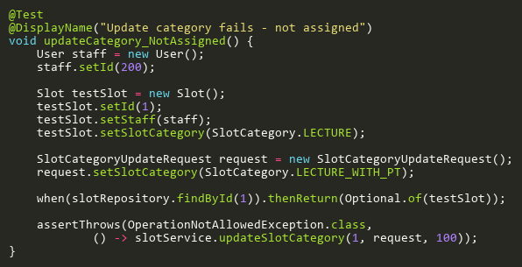

**Figure: updateCategory_NotAssigned**  
*Reference: Sheet "SLST_updateCategory", Test Case TC03*

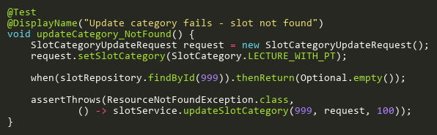

**Figure: updateCategory_NotFound**  
*Reference: Sheet "SLST_updateCategory", Test Case TC04*

## UpdateTests

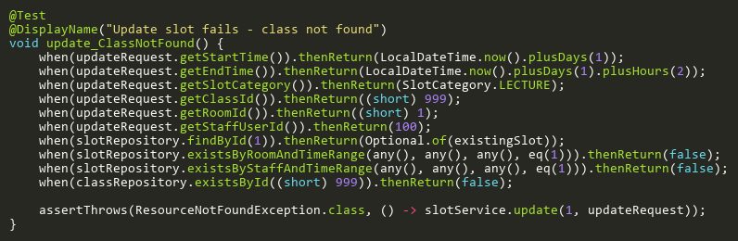

**Figure: update_ClassNotFound**  
*Reference: Sheet "SLST_update", Test Case TC07*

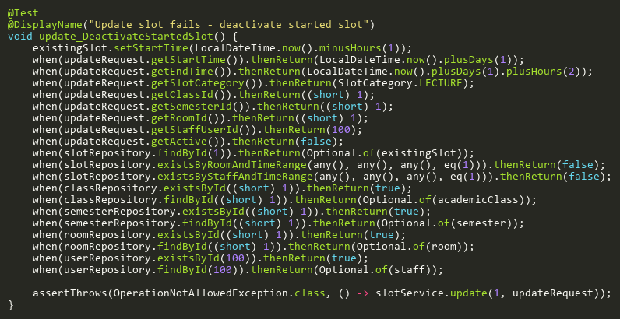

**Figure: update_DeactivateStartedSlot**  
*Reference: Sheet "SLST_update", Test Case TC10*

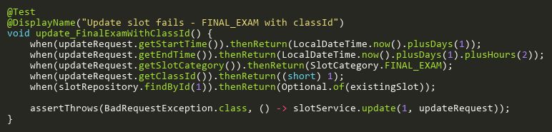

**Figure: update_FinalExamWithClassId**  
*Reference: Sheet "SLST_update", Test Case TC03*

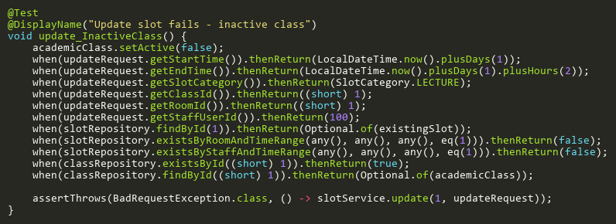

**Figure: update_InactiveClass**  
*Reference: Sheet "SLST_update", Test Case TC08*

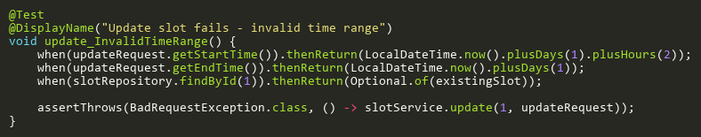

**Figure: update_InvalidTimeRange**  
*Reference: Sheet "SLST_update", Test Case TC02*

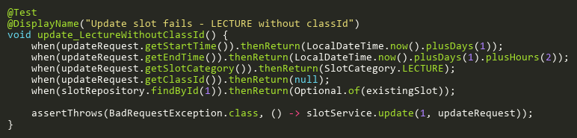

**Figure: update_LectureWithoutClassId**  
*Reference: Sheet "SLST_update", Test Case TC04*

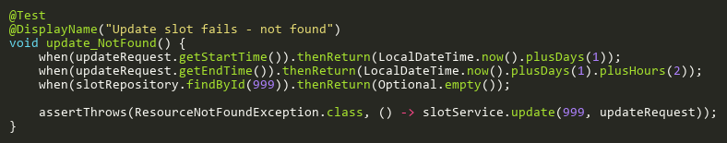

**Figure: update_NotFound**  
*Reference: Sheet "SLST_update", Test Case TC01*

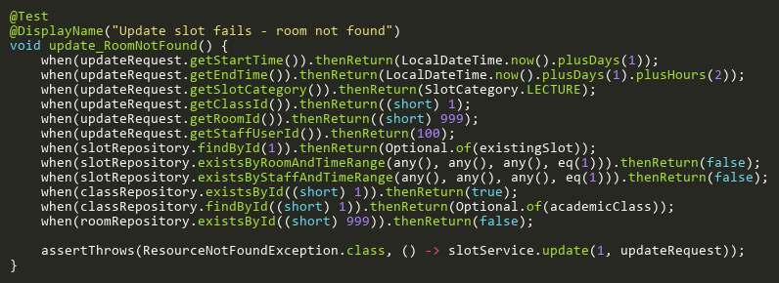

**Figure: update_RoomNotFound**  
*Reference: Sheet "SLST_update", Test Case TC09*

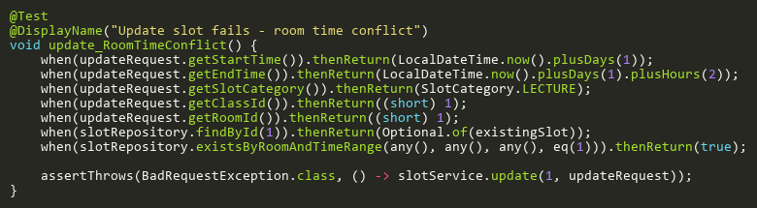

**Figure: update_RoomTimeConflict**  
*Reference: Sheet "SLST_update", Test Case TC05*

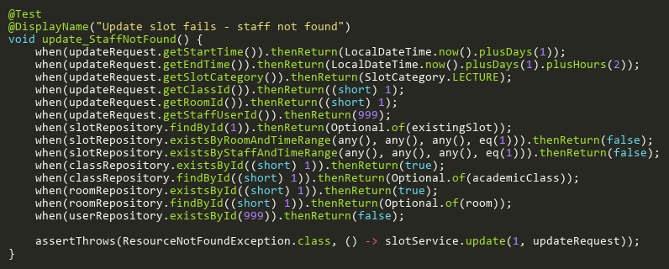

**Figure: update_StaffNotFound**  
*Reference: Sheet "SLST_update", Test Case TC13*

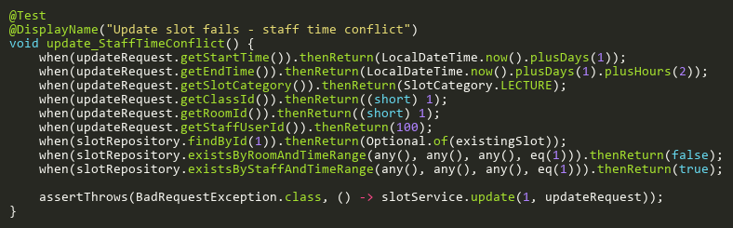

**Figure: update_StaffTimeConflict**  
*Reference: Sheet "SLST_update", Test Case TC06*

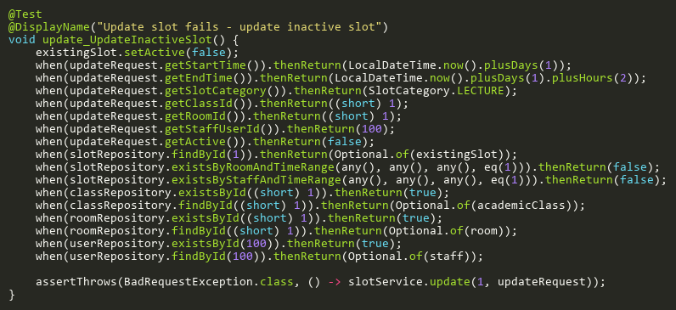

**Figure: update_UpdateInactiveSlot**  
*Reference: Sheet "SLST_update", Test Case TC11*